Name _____________________________

**Cells Alive- Internet Lesson**

URL: http://www.cellsalive.com

Objective: You will look at computer models of cells; learn the functions and the descriptions of the cells and their components.

***Navigating the site: *Cells alive* has a navigation bar at the left. After accessing the page, click on CELL MODELS on the left side navigation bar. From here, scroll down and click on “TAKE ME TO THE ANIMATION.”

Have you read the above directions?



**Part A: Animal Cell Model** - (you will need to click on the green words that say “Animal Cell”)

For this model, you will need to click on the various parts of the cell to go to a screen that tells you about the parts. Answers to the following questions and make the sketches.

|  |  |  |  |  |  |
| --- | --- | --- | --- | --- | --- |
| 1. What do mitochondria do?    2. How big are mitochondria?    3. What does the Golgi Apparatus do?    4. What is the difference between smooth and rough ER?    5. Where is the nucleolus found?    6. What does the nucleolus do?    7. What is the function of the lysosome? | Sketch each of the following.   |  | | --- | | Mitochondria | | Lysosome | | Golgi Apparatus | | Rough ER | |

**Part B: Plant Cell Model** - (you will need to click on the green words that say “Plant Cell”-right above the list of organelles)

For this model, you will need to click on the various parts of the cell to go to a screen that tells you about the parts. Answers to the following questions and make the sketches.

|  |  |  |  |
| --- | --- | --- | --- |
| 1. What other type of cell has a cell wall?    2. What makes the plant cells green?    3. In plant cells, what does the vacuole do? | Sketch the following   |  | | --- | | Chloroplast | | Vacuole | |

**Part C: Bacterial Cell Model-** (you will need to click on the “CELL MODELS” link on the navigation list on the left side of the page. Scroll all the way down until you see “TAKE ME TO THE BACTERIAL CELL”-click on that)

For this model, you will need to look at the various parts of the cell and label the bacterial cell.

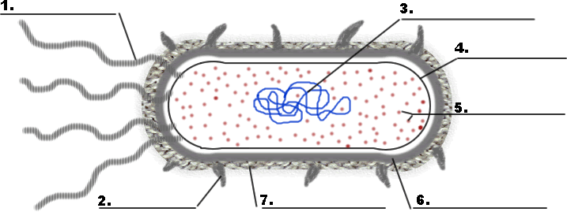

**Part D: Overview**

For the chart below, place a check in the box if the cell has that component.

|  |  |  |  |
| --- | --- | --- | --- |
|  | Plant | Animal | Bacteria |
| Chloroplast |  |  |  |
| Vacuole |  |  |  |
| Ribosome |  |  |  |
| Mitochondria |  |  |  |
| DNA |  |  |  |
| Endoplasmic Reticulum |  |  |  |
| Cell Wall |  |  |  |
| Golgi Apparatus |  |  |  |