Chapter: Studying Earth’s Surface

Introduction to Earth’s Surface

Lesson Objectives
- Distinguish between location and direction.
- Describe topography.
- Identify various landforms and briefly describe how they came about.

Location
Wherever you are on Earth’s surface, in order to describe your location, you need some point of reference. Right now you are probably reading this chapter at your computer. But where is your computer? It may set up in a certain place or you may be on a laptop computer, which means you can change where you are. In order to describe your location, you could name other items around you to give a more exact position of your computer. Or you could measure the distance and direction that you are from a reference point. For example, you may be sitting in a chair that is one meter to the right of the door. This statement provides more precise information for someone to locate your position within the room.
Similarly, when studying the Earth’s surface, Earth scientists must be able to pinpoint any feature that they observe and be able to tell other scientists where this feature is on the Earth’s surface. Earth scientists have a system to describe the location of any feature. To describe your location to a friend when you are trying to get together, you could do what we did with describing the location of the computer in the room. You would give her a reference point, a distance from the reference point, and a direction, such as, “I am at the corner of Maple Street and Main Street, about two blocks north of your apartment." Another way is to locate the feature on a coordinate system, using latitude and longitude. Lines of latitude and longitude form a grid that measures distance from a reference point. You will learn about this type of grid when we discuss maps later in this chapter.

Direction
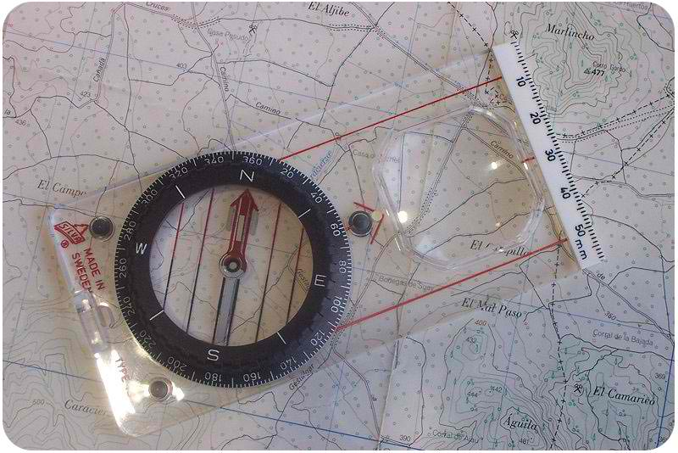
If you are at a laptop, you can change your location. When an object is moving, it is not enough to describe its location; we also need to know direction. Direction is important for describing moving objects. For example, a wind blows a storm over your school. Where is that storm coming from? Where is it going? The most common way to describe direction in relation to the Earth’s surface is by using a compass. The compass is a device with a floating needle that is a small magnet (Figure LEFT). The needle aligns itself with the Earth’s magnetic field, so that the compass needle points to magnetic north. Once you find north, you can then describe any other direction, such as east, south, west, etc., on a compass rose (Figure below).
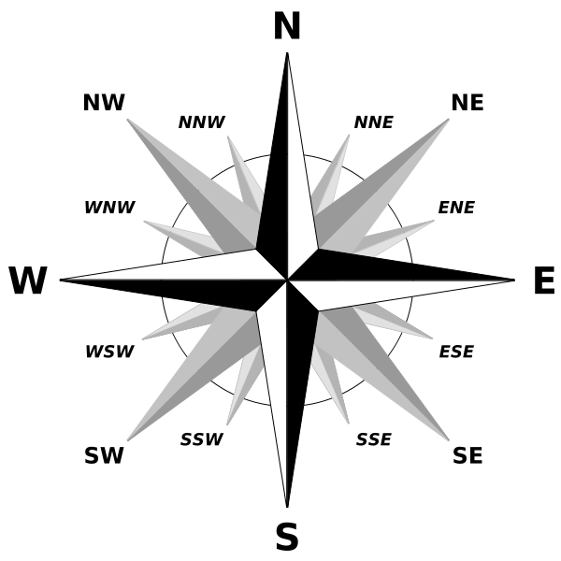
A compass rose shows the various directions, such as North (N), East (E), South (S), West (W) and various combinations.
A compass needle aligns to the Earth’s magnetic North Pole, not the Earth’s geographic North Pole or true north. The geographic North Pole is the top of the imaginary axis upon which the Earth’s rotates, much like the spindle of a spinning top. The magnetic North Pole shifts in location over time. Depending on where you live, you can correct for this difference when you use a map and a compass (Figure below).

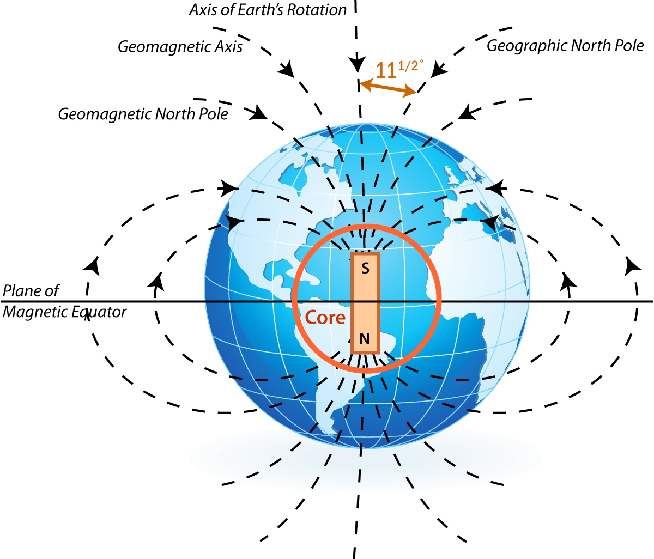
Earth
When you study maps later, you will see that certain types of maps have a double compass rose to make the corrections between magnetic north and true north. An example of this type is a nautical chart that sailors and boaters use to chart their positions at sea or offshore (Figure below).

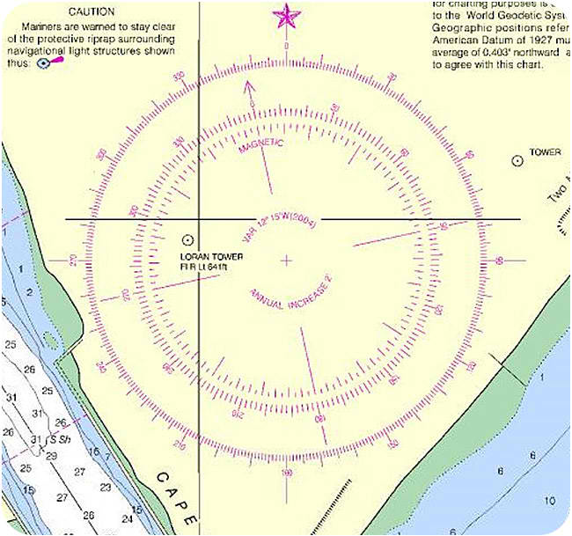
Nautical maps include a double compass rose that shows both magnetic directions (inner circle) and geographic compass directions (outer circle).

Topography
As you know, the surface of the Earth is not flat. Some places are high and some places are low. For example, mountain ranges like the Sierra Nevada in California or the Andes mountains in South America are high above the surrounding areas. We can describe the topography of a region by measuring the height or depth of that feature relative to sea level (Figure below). You might measure your height relative to your best friend or classmate. When your class lines up, some kids make high “mountains” and others are more like small hills!

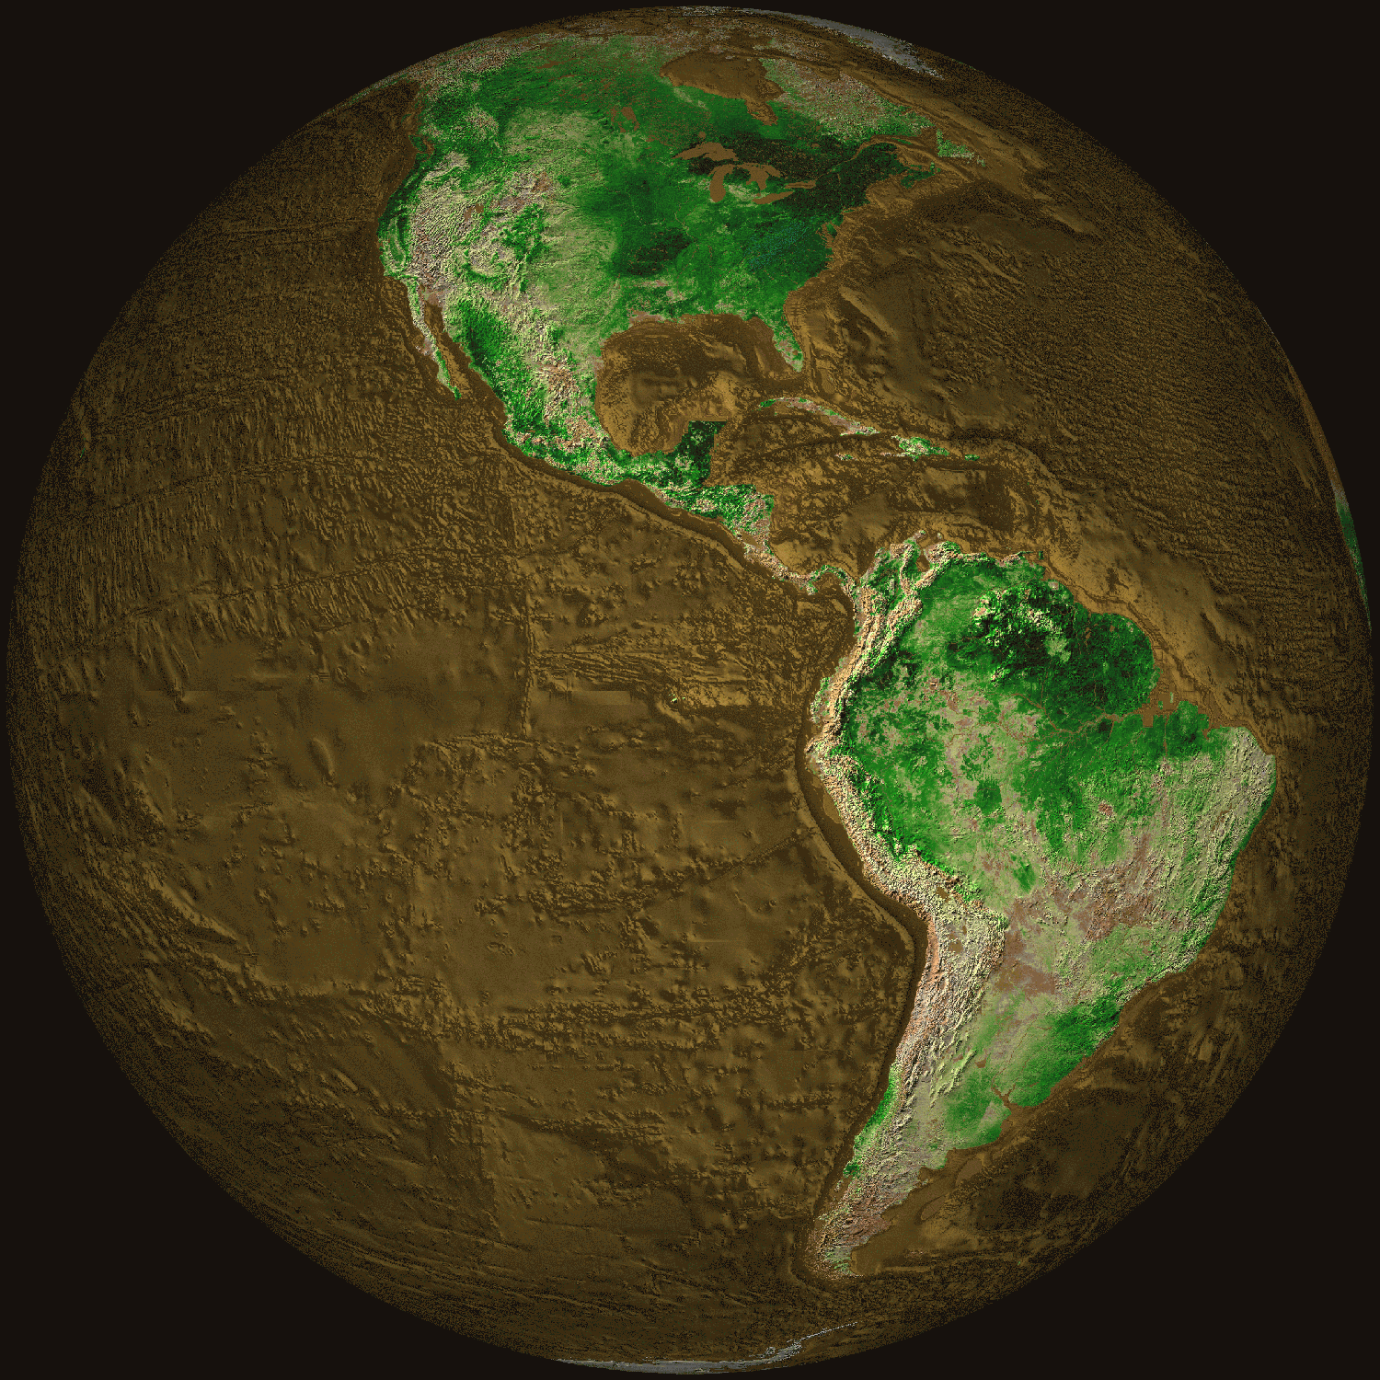
Topographical map of the Earth showing North America and South America.
What scientists call relief or terrain includes all the major features or landforms of a region. A topographic map of an area shows the differences in height or elevation for mountains, craters, valleys, and rivers. For example, Figure below shows the San Francisco Mountain area in northern Arizona as well as some nearby lava flows and craters. We will talk about some different landforms in the next section.
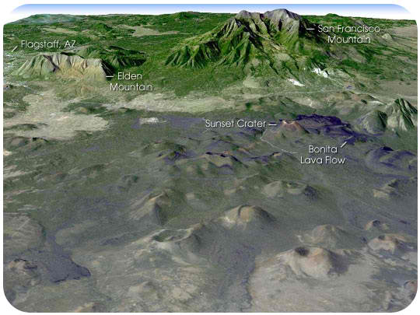
This image was made from data of the Landsat satellite and shows the topography of the San Francisco Mountain and surrounding areas in northern Arizona. You can see the differences in elevation of the mountain and surrounding lava flows.

Landforms
If you look at the Earth’s surface and take away the water in the oceans (Figure below), you will see that the surface has two distinctive features, continents and the ocean basins. The continents are large land areas extending from high elevations to sea level. The ocean basins extend from the edges of the continents down steep slopes to the ocean floor and into deep trenches.
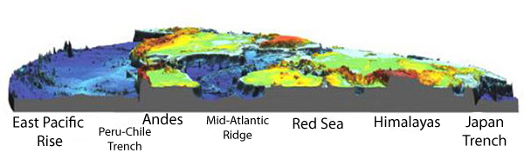
This image shows examples of some of the main features found on the ocean floor, as well as their above-water continuations. The red areas are high elevations (mountains). Yellow and green areas are lower elevations and blue areas are the lowest on the ocean floor. (i.e., the image below is a slice through a relief map of world.
Both the continents and the ocean floor have many features with different elevations. Some areas of the continents are high. These are the mountains we have already talked about. Even on the ocean floor there are mountains! Let’s discuss each.

Continents
Continents are relatively old (billions of years) compared to the ocean basins (millions of years). Because the continents have been around for billions of years, a lot has happened to them! As continents move over the Earth’s surface, mountains are formed when continents collide. Once a mountain has formed, it gradually wears down by weathering and erosion. Every continent has mountain ranges with high elevations (Figure below). Some mountains formed a very long time ago and others are still forming today:
- Young mountains (< 100 million years) – Mountains of the Western United States (Rocky Mountains, Sierra Nevada, Cascades), Mountains around the edge of the Pacific Ocean, Andes Mountains (South America), Alps (Europe), Himalayan Mountains (Asia)
- Old mountains (> 100 million years) – Appalachian Mountains (Eastern United States), Ural Mountains (Russia).
Mountains can be formed when the Earth’s crust pushes up, as two continents collide, like the Appalachian Mountains in the eastern United States and the Himalayas in Asia. Mountains can also be formed by a long chain of volcanoes at the edge of a continent, like the Andes Mountains in South America.
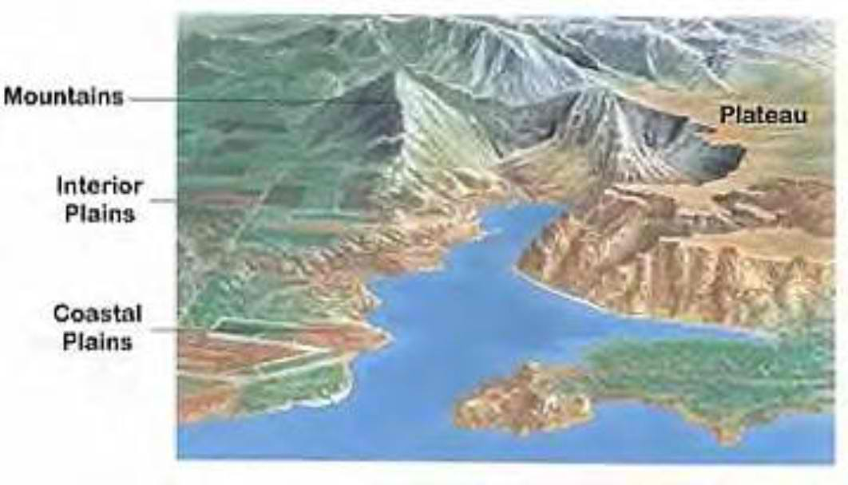
Features of continents include mountain ranges, plateaus, and plains.
Over millions of years, mountains are worn down by rivers and streams to form high flat areas called plateaus or lower lying plains. Interior plains are in the middle of continents while coastal plains are on the edge of a continent, where it meets the ocean.
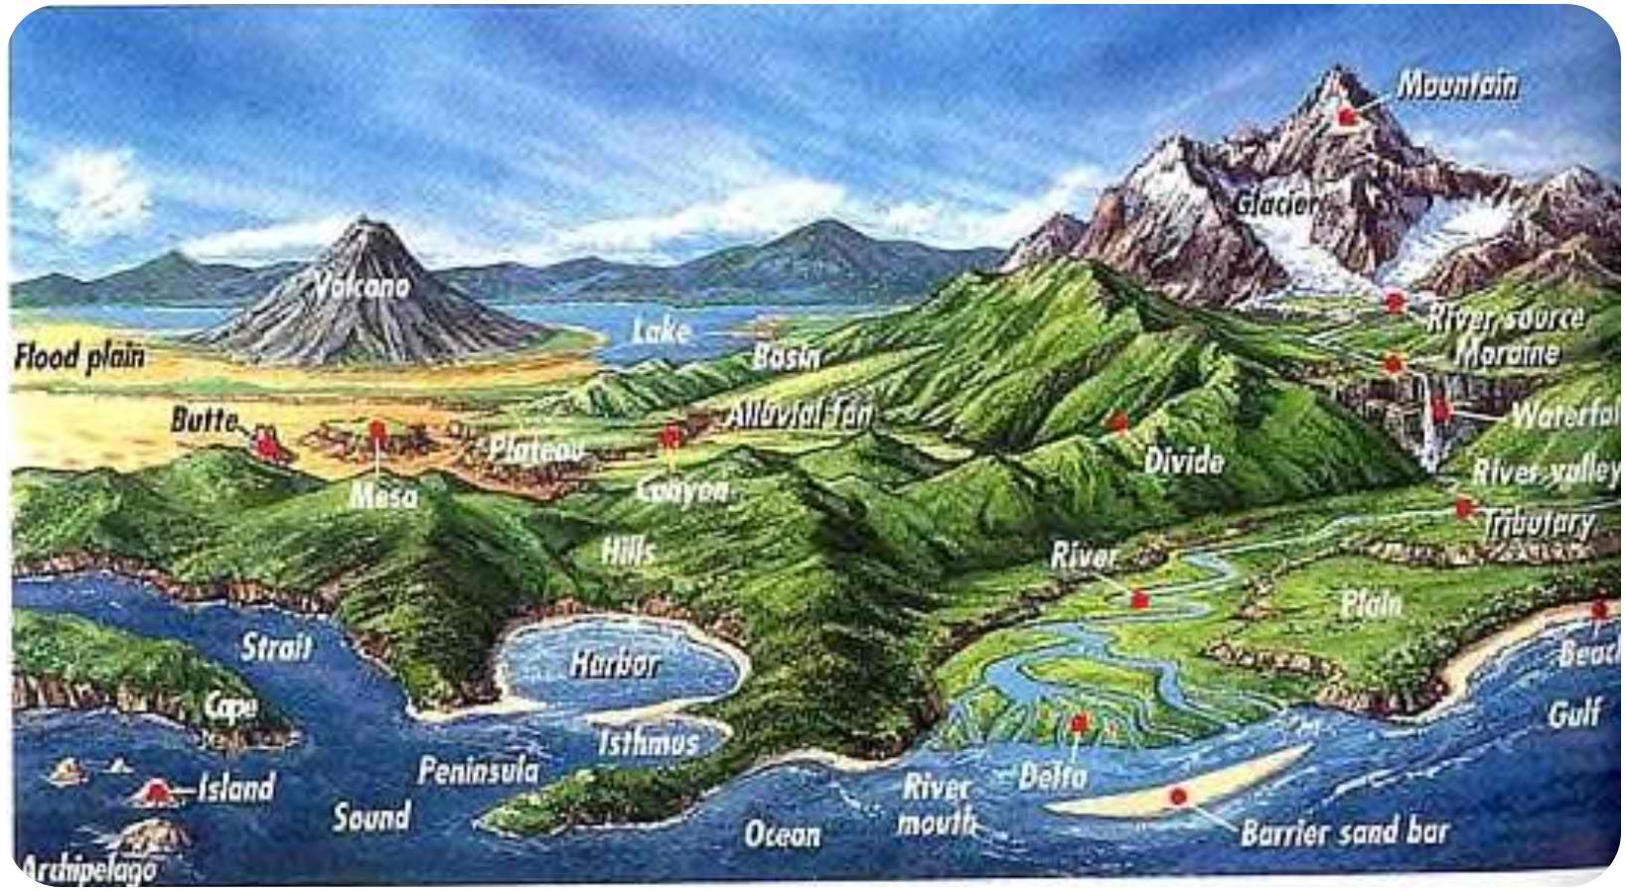
Summary of major landforms on continents and features of coastlines.
As rivers and streams flow across continents, they cut away at rock, forming river valleys (Figure above). The bits and pieces of rock carried by rivers are deposited where rivers meet the oceans. These can form deltas, like the Mississippi River delta and barrier islands, like Padre Island in Texas. Our rivers bring sand to the shore which forms our beaches.

Ocean Basins
The ocean basins begin where the ocean meets the land. The names for the parts of the ocean nearest to the shore still have the word “continental” attached to them because the continents form the edge of the ocean. The continental margin is the part of the ocean basin that begins at the coastline and goes down to the ocean floor. It starts with the continental shelf, which is a part of the continent that is underwater today. The continental shelf usually goes out about 100 – 200 kilometers and is about 100-200 meters deep, which is a very shallow area of the ocean (Figure below).
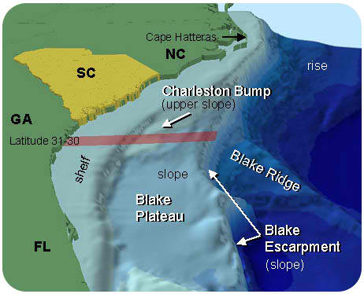
Diagram of the continental shelf and slope of the southeastern United States leading down to the ocean floor.
From the edge of the continental shelf, the continental slope is the hill that forms the edge of the continent. As we travel down the continental slope, before we get all the way to the ocean floor, there is often a large pile of sediments brought from rivers, which forms the continental rise. The continental rise ends at the ocean floor, which is called the abyssal plain.
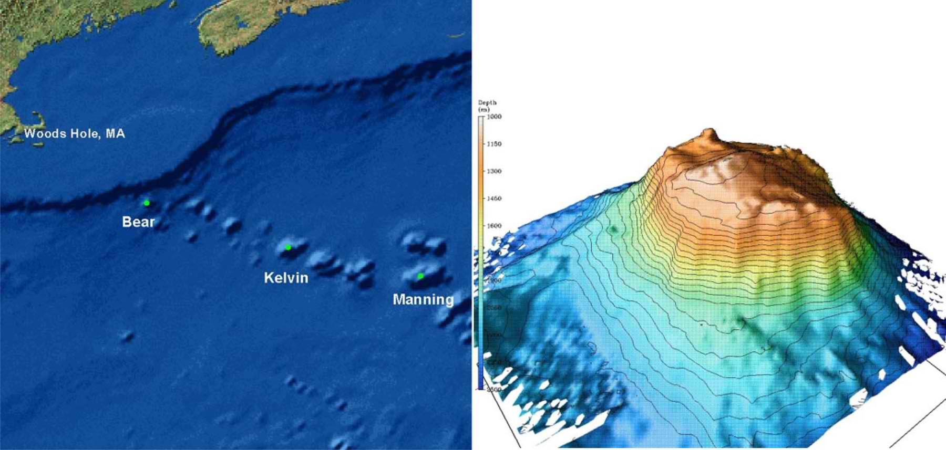
A chain of seamounts is located off the coast of New England (left) and oceanographers mapped one of these seamounts called Bear Seamount in great detail (right).
The ocean floor itself is not totally flat. Small hills rise above the thick layers of mud that cover the ocean floor. In many areas, small undersea volcanoes, called seamounts (Figure above) rise more than 1000 m above the seafloor. Besides seamounts, there are long, very tall (about 2 km) mountain ranges that form along the middle parts of all the oceans. They are connected in huge ridge systems called mid-ocean ridges (Figure below). The mid-ocean ridges are formed from volcanic eruptions, when molten rock from inside the Earth breaks through the crust, flows out as lava and forms the mountains.
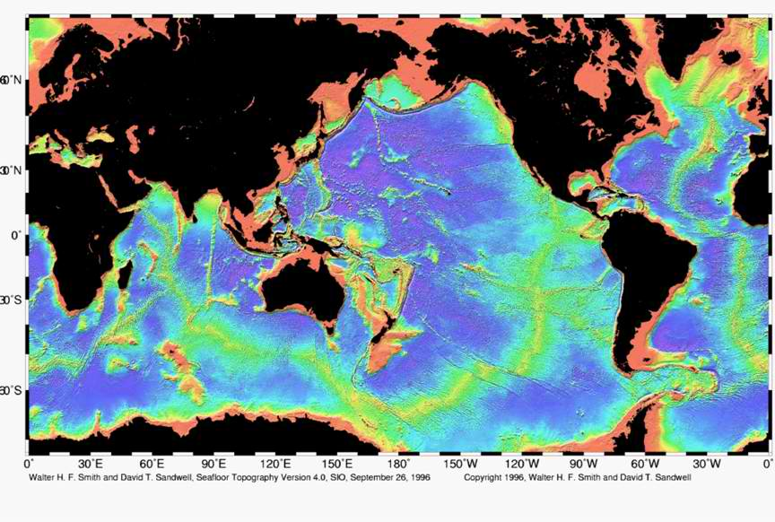
Map of the mid-ocean ridge system (yellow-green) in the Earth
The deepest places of the ocean are the ocean trenches. There are many trenches in the world’s oceans, especially around the edge of the Pacific Ocean. The Mariana Trench, which is located east of Guam in the Pacific Ocean, is the deepest place in the ocean, about 11 kilometers deep (Figure below). To compare the deepest place in the ocean with the highest place on land, Mount Everest is less than 9 kilometers tall. In these trenches, the ocean floor sinks deep inside the Earth. The ocean floor gets constantly recycled. New ocean floor is made at the mid-ocean ridges and older parts are destroyed at the trenches. This recycling is why the ocean basins are so much younger than the continents.
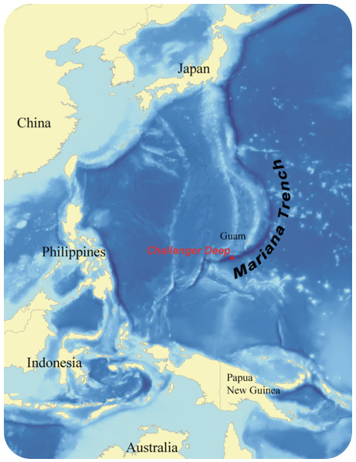
This map shows the location of the Mariana Trench in the Pacific Ocean.
The Earth’s surface is constantly changing over long periods of time. For example, new mountains get formed by volcanic activity or uplift of the crust. Existing mountains and continental landforms get worn away by erosion. Rivers and streams cut into the continents and create valleys, plains, and deltas. Underneath the oceans, new crust forms at the mid-ocean ridges, while old crust gets destroyed at the trenches. Wave activity erodes the tops of some seamounts and volcanic activity creates new ones. You will explore the ways that the Earth’s surface changes as you proceed through this book.

Lesson Summary
- Earth scientists must be able to describe the exact positions or locations of features on the Earth’s surface.
- Positions often include distances and directions. To determine direction, you can use a compass, which has a tiny magnetic needle that points toward the Earth’s magnetic North Pole. Once you have found north, you can find east, west and south, using your compass for reference.
- Topography describes how the Earth’s surface varies in elevation. Mountains form the highest areas. Valleys and trenches form the lowest areas. Both continents and ocean basins have mountains and mountain ranges. They each also have plateaus, plains, and valleys or trenches.
- Mountains form as continents collide and as volcanoes erupt. Mountains are worn away by wind and water. The earth’s surface is constantly changing due to these creative and destructive processes.

Review Questions
- What information might you need to describe the location of a feature on the Earth’s surface?
- Why would you need to know direction if an object is moving?
- Explain how new ocean floor is created and also how ocean crust is destroyed. Why are the ocean basins younger than the continents?
- Why do nautical charts have two compass roses on them
- What landforms are the highest on the continents?
- Explain what landforms on the continents are created by erosion from wind and water. How does erosion create a landform?
- What is topography?

Further Reading/Supplemental Links
- http://www.cerritos.edu/earth-science/tutor/landform_identification. htm
- http://www.enotes.com/earth-science/landforms
- http://oceanexplorer.noaa.gov/explorations/04etta/welcome

Vocabulary
abyssal plain
The very flat, deep ocean floor.
barrier island
A long, narrow island parallel to the shore.
beaches
Areas along the shore where sand or gravel accumulates.
compass
Hand-held device with a magnetic needle used to find magnetic north.
compass rose
Figure on a map or nautical chart for displaying locations of north, south, east and west.
continent
Land mass above sea level.
continental margin
Submerged, outer edge of the continent.
continental rise
Gently sloping accumulation of sediments that forms where the continental slope meets the ocean floor.
continental shelf
Very gently sloping portion of the continent covered by the ocean.
continental slope
Sloping, underwater edge of the continent.
delta
Often triangular shaped deposit of sediment at the mouth of a river.
elevation
Height of a feature measured relative to sea level.
mid-ocean ridge
A large, continuous mountain range found in the middle of an ocean basin; marks a divergent plate boundary.
ocean basins
Areas covered by ocean water.
plains
Low lying continental areas, can be inland or coastal.
plateaus
Flat lying, level elevated areas.
relief
Difference in height of landforms in a region.
river valleys
Areas formed as water erodes the landscape, often 'V' shaped.
seamount
Underwater, volcanic mountain more than 1000 meters tall.
topography
Changes in elevation for a given region.

Points to Consider
- A volcano creates a new landform in Mexico. As the earth scientist assigned to study this feature, explain how you would describe its position in a report or scientific communication?
- Suppose you wanted to draw a map to show all the changes in elevation around the area where you live. How might you show low areas and high areas? What would you do if you wanted this map to show these changes as if you were flying above your home?
- Why do you think continents are higher areas on Earth than our ocean basins?

Modeling Earth’s Surface

Lesson Objectives
- Describe what information a map can convey.
- Identify some major types of map projections and discuss the advantages and disadvantages of each.
- Discuss the advantages and disadvantages of using a globe.

Maps as Models
Imagine you are going on a road trip. Perhaps you are going on vacation. How do you know where to go? Most likely, you will use a map. Maps are pictures of specific parts of the Earth’s surface. There are many types of maps. Each map gives us different information. Let’s look at a road map, which is the probably the most common map that you use (Figure below).
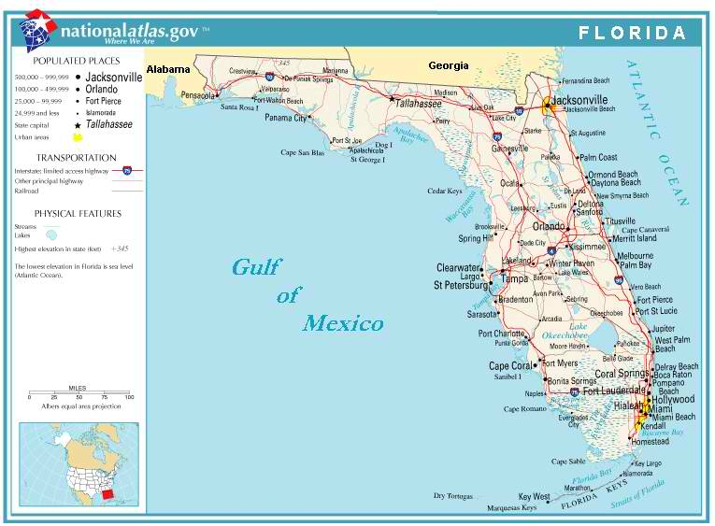
shows a road map of the state of Florida. What information can you get from this map?
Look for the legend on the top left side of the map. It explains how this map records different features. You can see the following:
- The boundaries of the state show its shape.
- Black dots represent the cities. Each city is named. The size of the dot represents the population of the city.
- Red and brown lines show major roads that connect the cities.
- Blue lines show rivers. Their names are written in blue.
- Blue areas show lakes and other waterways - the Gulf of Mexico, Biscayne Bay, and Lake Okeechobee. Names for bodies of water are also written in blue.
- A line or scale of miles shows the distance represented on the map – an inch or centimeter on the map represents a certain amount of distance (miles or kilometers).
- The legend explains other features and symbols on the map.
- Although this map does not have a compass rose, north is at the top of the map.
You can use this map to find your way around Florida and get from one place to another along roadways.
There are many other types of maps besides road maps. Some examples include:
- Topographic maps show detailed elevations of landscapes on the map.
- Relief maps show elevations of areas, but usually on a larger scale. Relief maps might show landforms on a global scale rather than a local area.
- Satellite view maps show terrains and vegetation – forests, deserts, and mountains.
- Climate maps show average temperatures and rainfall.
- Precipitation maps show the amount of rainfall in different areas.
- Weather maps show storms, air masses, and fronts.
- Radar maps also show storms and rainfall.
- Geologic maps detail the types and locations of rocks found in an area.
- Political or geographic maps show the outlines and borders of states and/or countries.
These are but a few types of maps that various earth scientists might use. You can easily carry a map around in your pocket or bag. Maps are easy to use because they are flat or two-dimensional. However, the world is three-dimensional. So, how do map makers represent a three-dimensional world on flat paper? Let’s see.

Map Projections
The Earth is a three-dimensional ball or sphere. In a small area, the Earth looks flat, so it is not hard to make accurate maps of a small place. When map makers want to map the Earth on flat paper, they use projections. Have you ever tried to flatten out the skin of a peeled orange? Or have you ever tried to gift wrap a soccer ball to give to a friend as a present? Wrapping a round object with flat paper is difficult. A projection is a way to represent the Earth’s curved surface on flat paper (Figure below).
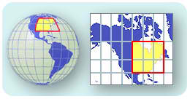
A map projection translates Earth's curved surface onto two dimensions.
There are many types of projections. Each uses a different way to change three-dimensions into two-dimensions.
There are two basic methods that the map maker uses in projections:
- The map maker “slices” the sphere in some way and unfolds it to make a flat map, like flattening out an orange peel.
- The map maker can look at the sphere from a certain point and then translate this view onto a flat paper.
Let’s look at a few commonly used projections.

Mercator Projection
In 1569, Gerardus Mercator (1512-1594) (Figure below) figured out a way to make a flat map of our round world, called a Mercator projection (Figure below). Imagine wrapping our round, ball shaped Earth with a big, flat piece of paper to make a tube or a cylinder. The cylinder will touch the Earth at the equator, the imaginary line running horizontally around the middle of the Earth, but the poles will be further away from the cylinder. If you could shine a light from the inside of your model Earth out to the cylinder, the image you would project onto the paper would be a Mercator projection. Your map would be just right at the equator, but the shapes and sizes of continents would get more stretched out for areas near the poles. Early sailors and navigators found the Mercator map useful because most explorers at that time traveled to settlements that were located near the equator. Many world maps still use Mercator projection today.
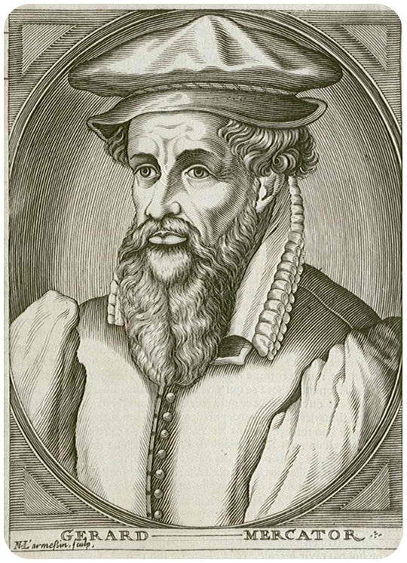
Gerardus Mercator developed a map projection used often today, known as the Mercator projection.
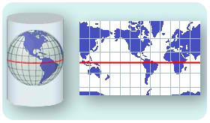
A Mercator projection translates the curved surface of Earth onto a cylinder.
The Mercator projection best describes the shapes and sizes of countries within 15 degrees north or south of the equator. For example, if you look at Greenland on a globe, you see it is a relatively small country near the North Pole. Yet on a Mercator projection, Greenland looks almost as big the United States. Greenland’s shape and size are greatly increased, while the United States is represented closer to its true dimensions. In a Mercator projection, all compass directions are straight lines, which makes it a good type of map for navigation. The top of the map is north, the bottom is south, the left side is west and the right side is east. However, because it is a flat map of a curved surface, a straight line on the map is not the shortest distance between the two points it connects.
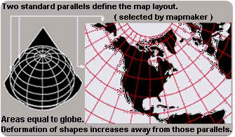
A conic map projection wraps the Earth with a cone shape rather than a cylinder.
Instead of a cylinder, you might try wrapping the flat paper into a cone. Conic map projections use a cone shape to better represent regions equally (Figure above). This type of map does best at showing the area where the cone shape touches the globe, which would be along a line of latitude, like the equator. Maybe you don’t like trying to wrap a flat piece of paper around a round object at all. In this case, you could put a flat piece of paper right on the area that you want to map. This type of map is called a gnomonic map projection (Figure below). The paper only touches the Earth at one point, but it will do a good job showing sizes and shapes of countries near that point. The poles are often mapped this way, but it works for any area that you chose.
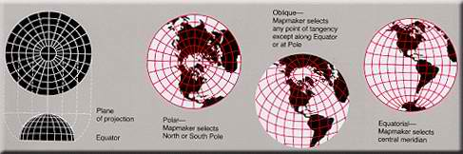
A gnomonic projection places a flat piece of paper on a point somewhere on Earth and projects an image from that point.

Robinson Projection
In 1963, Arthur Robinson made a map that looks better in terms of shapes and sizes. He translated coordinates onto the map instead of using mathematical formulas. He did this so that regions on the map would look right. This map is shaped like an ellipse (oval shape) rather than a rectangle (Figure below).
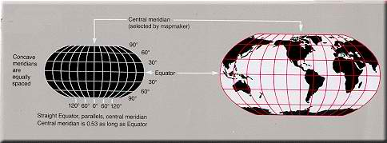
A Robinson projection uses mathematical formulas to best represent the true shapes and sizes of areas on Earth.
Robinson’s map shows less distortion near the poles and keeps shapes and sizes of continents close to their true dimensions, especially within 45 degrees of the equator. The distances along the equator and lines parallel to it are true, but the scales along each line of latitude are different. In 1988, the National Geographic Society adopted Robinson’s projection for all of its world maps. Whatever map projection is used, maps are designed to help us find places and to be able to get from one place to another. So how do you find your location on a map? Let’s look.

Map Coordinates
Most maps use a grid or coordinate system to find your location. This grid system is sometimes called a geographic coordinate system. The system defines your location by two numbers, latitude and longitude. Both numbers are angles that you make between your location, the center of the Earth, and a reference line (Figure below).
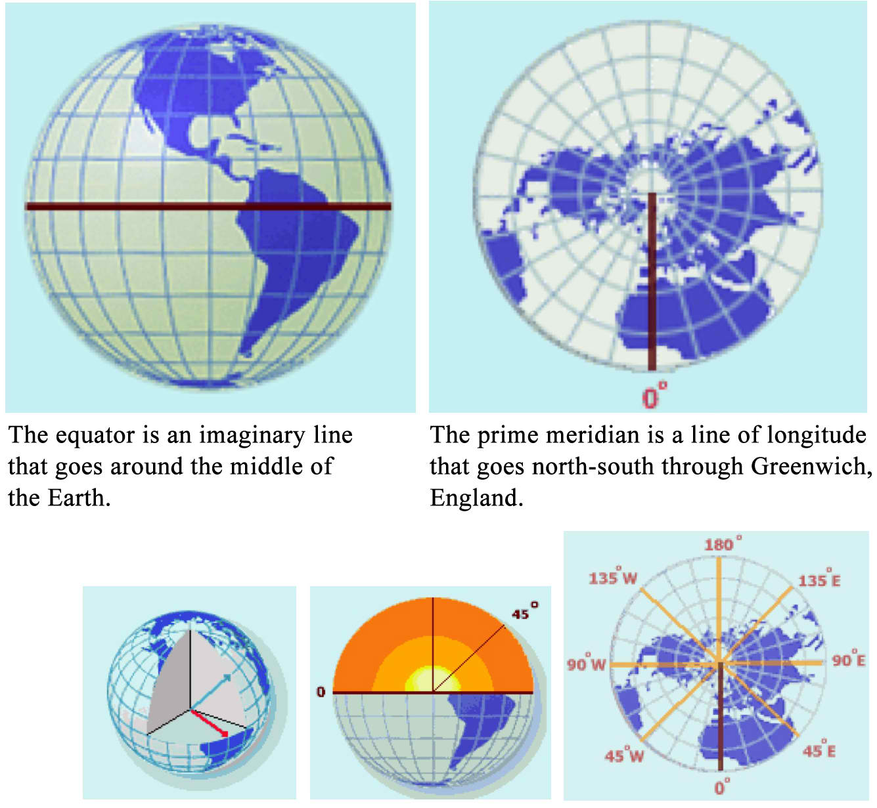
Lines of latitude start with the equator. Lines of longitude begin at the prime meridian.
Lines of latitude circle around the Earth. The equator is a line of latitude right in the middle of the Earth, which is the same distance from both the North and South Pole. In a grid, your latitude tells you how far you are north or south of the equator. Lines of longitude are circles that go around the Earth from pole to pole, like the sections of an orange. Lines of longitude start at the Prime Meridian, which is a circle that runs north to south and passes through Greenwich, England. Longitude tells you how far east or west you are from the Prime Meridian. You can remember latitude and longitude by doing jumping jacks. When your hands are above your head and your feet are together, say longitude (your body is long!), then when you put your arms out to the side horizontally, say latitude (your head and arms make a cross, like the “t” is latitude). While you are jumping, your arms are going the same way as each of these grid lines; horizontal for latitude and vertical for longitude.
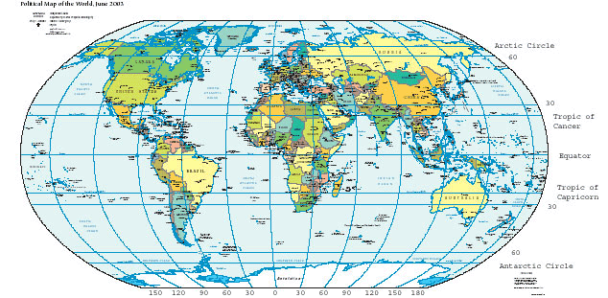
Lines of latitude and longitude form convenient reference points on a map.
If you know the latitude and longitude for a particular place, you can find it on a map. Simply place one finger on the latitude on the vertical axis of the map. Place your other finger on the longitude along the horizontal axis of the map. Move your fingers along the latitude and longitude lines until they meet. For example, if the place you want to find is at 30ºN and 90ºW, place your right finger along 30ºN at the right of the map (Figure above). Place your left finger along the bottom at 90ºW. Move them along the lines until they meet. Your location should be near New Orleans, Louisiana along the Gulf coast of the United States. Also, if you know where you are on a map, you can reverse the process to find your latitude and longitude.
One other type of coordinate system that you can use to go from one place to another is a polar coordinate system. Here your location is marked by an angle and distance from some reference point. The angle is usually the angle between your location, the reference point, and a line pointing north. The other number is a distance in meters or kilometers. To find your location or move from place to place, you need a map, a compass, and some way to measure your distance, such as a range finder. Suppose you need to go from your location to a marker that is 20ºE and 500 m from your current position. You must do the following:
- Use the compass and compass rose on the map to orient your map with North.
- Use the compass to find which direction is 20ºE.
- Walk 500 meters in that direction to reach your destination.
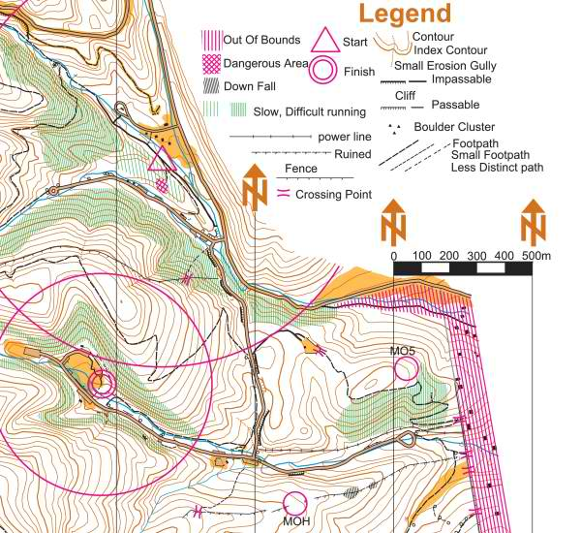
A topographic map like one that you might use for the sport of orienteering.
Polar coordinates are used most often in a sport called orienteering. Here, you use a compass and a map to find your way through a course across wilderness terrain (Figure above). You move across the terrain to various checkpoints along the course. You win by completing the course to the finish line in the fastest time.

Globe
A globe is the best way to make a map of the whole Earth, because the Earth is a sphere and so is a globe. Because both the Earth and a globe have curved surfaces, sizes and shapes of countries are not distorted and distances are true to scale. (Figure below).
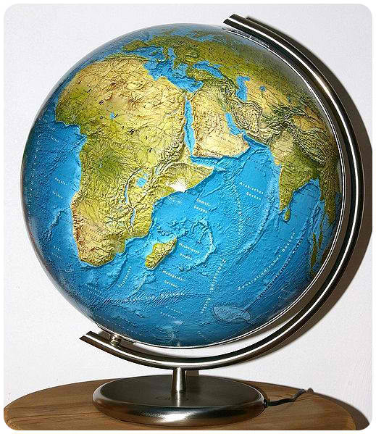
A globe is the most accurate way to represent Earth's curved surface.
Globes usually have a geographic coordinate system and a scale on them. The shortest distance between two points on a globe is the length of the arc (portion of a circle) that connects them. Despite their accuracy, globes are difficult to make and carry around. They also cannot be enlarged to show the details of any particular area. Google Earth is a neat site to download to your computer. This is a link that you can follow to get there: earth.google.com/download-earth.html. The maps on this site allow you to zoom in or out, look from above, tilt your image and lots more.

Lesson Summary
- Maps and globes are models of the Earth’s surface. There are many ways to project the three-dimensional surface of the Earth on to a flat map. Each type of map has some advantages as well as disadvantages.
- Most maps use a geographic coordinate system to help you find your location using latitude and longitude.
- Globes are the most accurate representations, because they are round like the Earth, but they cannot be carried around easily. Globes also cannot show the details of the Earth’s surface that maps can.

Review Questions
- Which of the following gives you the most accurate representations of distances and shapes on the Earth’s surface?
  - Mercator projection map
  - Robinson projection map
  - Globe
- Explain the difference between latitude and longitude?
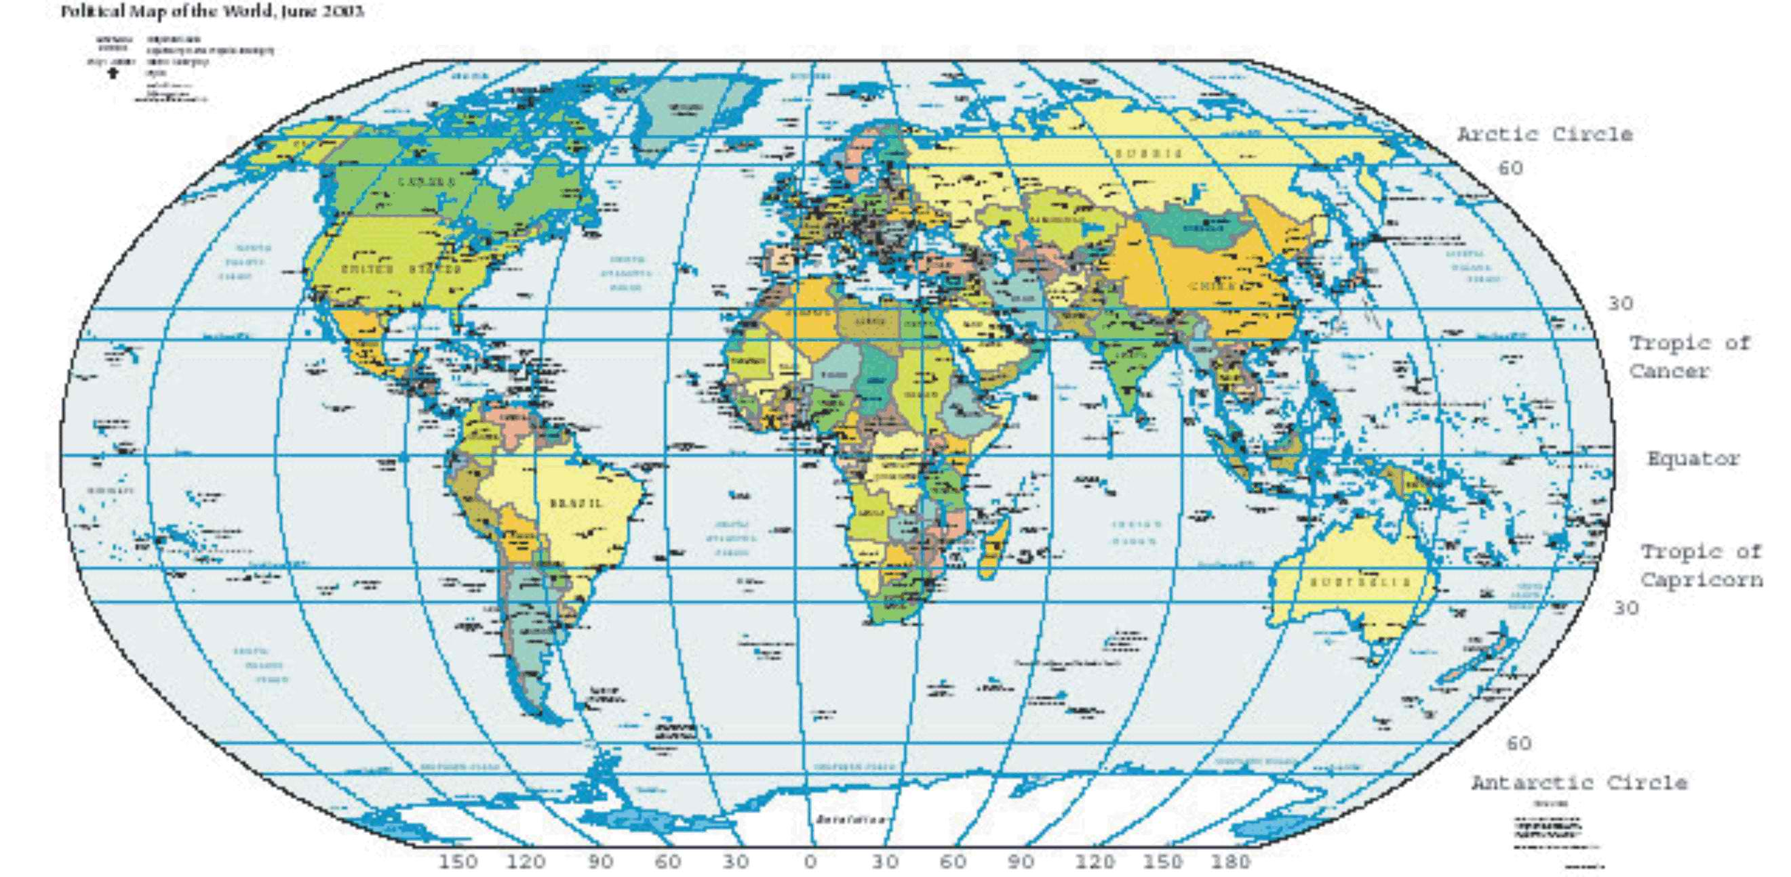
World map with geographic coordinate system
- Use (Figure above). In what country are you located, if your coordinates are 60ºN and 120ºW?
- Which map projection is most useful for navigation, especially near the equator? Explain
- In many cases, maps are more useful than a globe. Why?
- Which of the following map projections gives you the least distortion around the poles?
  - Mercator projection map
  - Robinson projection map
  - Conic projection

Further Reading / Supplemental Links
- http://erg.usgs.gov/isb/pubs/MapProjections/projections. html
- http://www.msnucleus.org/membership/html/jh/earth/mapstype/index.htm
- http://erg.usgs.gov/isb/pubs/booklets/usgsmaps/usgsmaps. html
- http://www.mywonderfulworld.org/toolsforadventure/usingmaps/ index.html, explorers.html
- http://maps.google.com/maps
- http://www.nationalatlas.gov/
- http://www.nationalatlas.gov/articles/mapping/a_projections. html
- http://www.nationalatlas.gov/articles/mapping/a_latlong html
- http://www.fao.org/docrep/003/T0390E/T0390E04.htm
- http://en.wikipedia.org/

Vocabulary
conic map
A map projection made by projecting Earth's three dimensional surface onto a cone wrapped around an area of the Earth.
coordinate system
Numbers in a grid that locate a particular point.
gnomonic map
A map projection made by projecting onto a flat paper from just one spot on the Earth.
latitude
An imaginary horizontal line drawn around the Earth parallel to the equator, which is 0º latitude.
longitude
An imaginary vertical line drawn on the Earth, from pole to pole; the Prime Meridian is 0º longitude.
map
A two dimensional representation of Earth's surface.
Mercator projection
A map projection created by Mercator using a cylinder wrapped around the Earth.
projection
A way to represent a three dimensional surface in two dimensions.

Points to Consider
- Imagine you are a pilot and must fly from New York to Paris. Use a globe and a world map to do the following:
  - Plot your course from New York to Paris on a globe. Make it the shortest distance possible.
  - Measure the distance by using the scale, a ruler, and a string.
  - Draw the course from the globe on a world map.
  - Draw a line on the map connecting New York and Paris.
- How does the course on the globe compare with the line on the map? Which is the shortest distance? Write a brief paragraph describing the differences and explain why they are different.
- Would you choose a map that used a Mercator projection if you were going to explore Antarctica? Explain why this would not be a good choice. What other type of map would be better?
- Maps use a scale, which means a certain distance on the map equals a larger distance on Earth. Why are maps drawn to scale? What would be some problems you would have with a map that did not use a scale?

Topographic Maps

Lesson Objectives
- Describe a topographic map.
- Explain what information a topographic map contains.
- Explain how to read and interpret a topographic map.
- Explain how various earth scientists use topographic maps to study the Earth.

What is a Topographic Map?
Mapping is a crucial part of earth science. Topographic maps represent the locations of major geological features. Topographic maps use a special type of line, called a contour line, to show different elevations on a map. Contour lines are drawn on a topographic map to show the location of hills, mountains and valleys. When you use a regular road map, you can see where the roads go, but a road map doesn’t tell you why a road stops or bends.A topographic map will show you that the road bends to go around a hill or stops because that is the top of a mountain. Let’s look at topographic maps.
Look at this view of the Swamp Canyon Trail in Bryce Canyon National Park, Utah (Figure below). You can see the rugged canyon walls and valley below. The terrain clearly has many steep cliffs. There are high and low points between the cliffs.
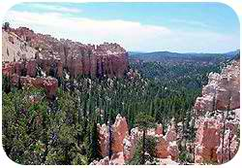
View of Swamp Canyon in Bryce Canyon National Park, looking southeast from Swamp Canyon Trail overlook.
Now look at the corresponding section of the Visitor’s map (Figure below). You can see a green line which is the main road. The black dotted lines are trails. You see some markers for campsites, a picnic area, and a shuttle bus stop. But nothing on the map shows the height of the terrain. Where are the hills and valleys located? How high are the canyon walls? Which way will streams or rivers flow?
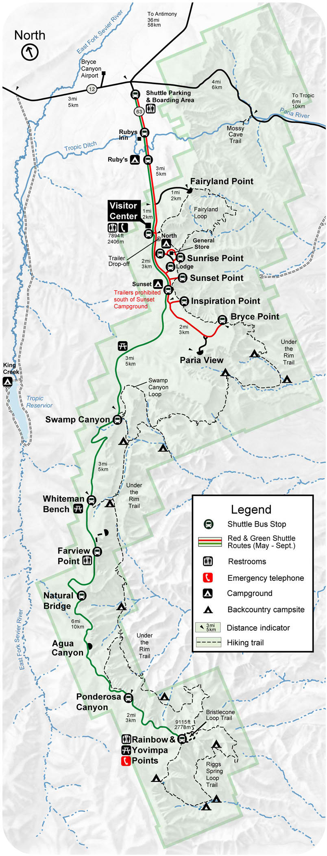
Portion of Bryce Canyon National Park road map showing Swamp Canyon Loop.
You need a special type of map to represent the elevations in an area. This type of map is called a topographic map (Figure below).
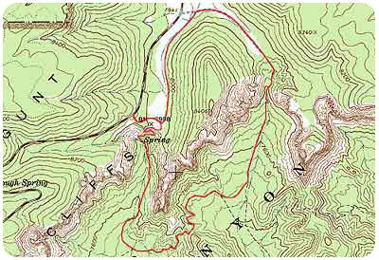
Topographic map of Swamp Canyon Trail portion of Bryce Canyon National Park.
What makes a topographic map different from other maps? Contour lines help show various elevations.

Contour Lines and Intervals
Contour lines connect all the points on the map that have the same elevation. Let’s take a closer look at this (Figure above).
- Each contour line represents a specific elevation and connects all the places that are at the same elevation. Every fifth contour line is bolded. The bold contour lines are labeled with numerical elevations.
- The contour lines run next to each other and NEVER cross one another. That would mean one place had two different elevations, which cannot happen.
- Two contour lines next to one another are separated by a constant difference in elevation (e.g. 20 ft or 100 ft.). This difference between contour lines is called the contour interval. You can calculate the contour interval. The legend on the map will also tell you the contour interval.
  - Take the difference in elevation between 2 bold lines.
  - Divide that difference by the number of contour lines between them.
If the difference between two bold lines is 100 feet and there are five lines between them, what is the contour interval? If you answered 20 feet, then you are correct (100 ft/5 = 20 ft)

Interpreting Contour Maps
How does a topographic map tell you about the terrain? Well, in reading a topographic map, consider the following principles:
1. Contour lines can indicate the slope of the land. Closely-spaced contour lines indicate a steep slope, because elevation changes quickly in a small area. In contrast, broadly spaced contour lines indicate a shallow slope. Contour lines that seem to touch indicate a very steep or vertical rise, like a cliff or canyon wall. So, contour lines show the three-dimensional shape of the land. For example, on this topographic map of Stowe, Vermont (Figure below), you will see a steep hill rising just to the right of the city of Stowe. You can tell this because the contour lines there are closely spaced. Using the contour lines, you can see that the hill has a sharp rise of about 200 ft and then the slope becomes less steep as you proceed right.
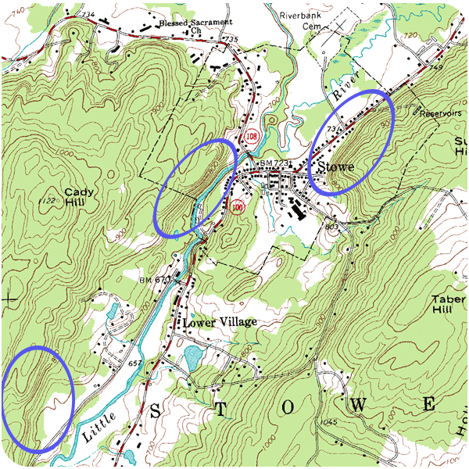
Portion of a USGS topographic map of Stowe, VT. In this map, you can see how the spacings of the contour lines indicate a steep hill just to the right of the city of Stowe in the right half. The hill becomes less steep as you proceed right.
2. Concentric circles indicate a hill. Figure below shows another side of the topographic map of Stowe, Vermont. When contour lines form closed loops all together in the same area, this is a hill. The smallest loops are the higher elevations and the larger loops are downhill. If you look at the map, you can see Cady Hill in the lower left and another, and another smaller hill in the upper right.
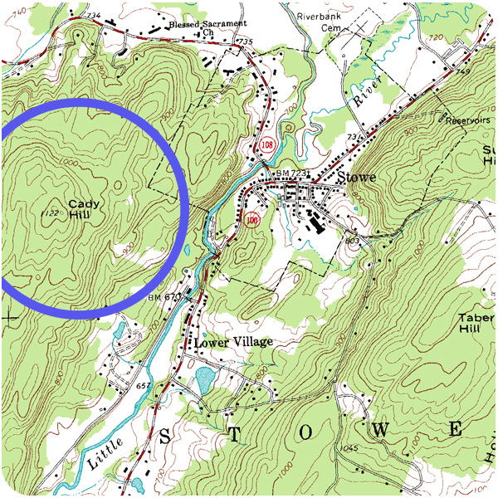
Portion of a USGS topographic map of Stowe, VT. In this map, you can see Cady Hill (elevation 1122 ft) indicated by concentric circles in the lower left portion of the map and another hill (elevation ~ 960 ft) in the upper right portion of the map.
3. Hatched concentric circles indicate a depression. The hatch marks are short, perpendicular lines inside the circle. The innermost hatched circle would represent the deepest part of the depression, while the outer hatched circles represent higher elevations (Figure below).
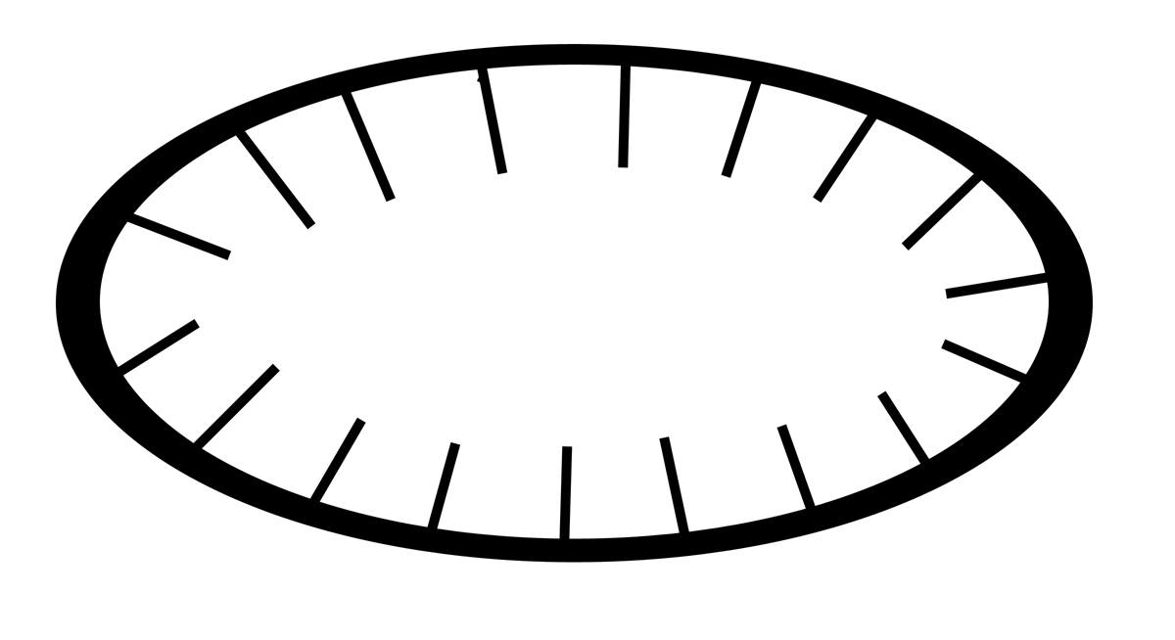
On a contour map, a circle with inward hatches indicates a depression.
4. V-shaped portions of contour lines indicate stream valleys. Here the V- shape of the contour lines “point” uphill. The channel of the stream passes through the point of the V and the open end of the V represents the downstream portion. Thus, the V points upstream. A blue line will indicate the stream if water is actually running through the valley; otherwise, the V patterns will indicate which way water will flow In Figure below, you can see examples of V-shaped markings. Try to find the direction a stream would flow.
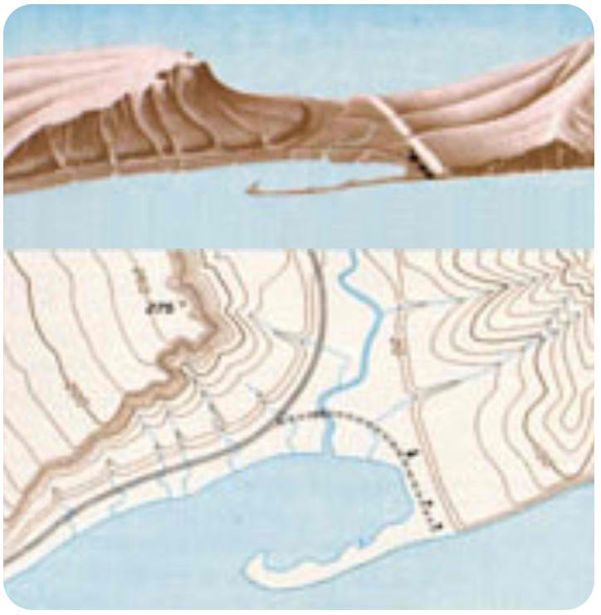
Illustrations of 3-dimensional ground configurations (top) and corresponding topographic map (bottom). Note the V-shaped markings on the topographic maps correspond to drainage channels. Also, the closely-spaced contour lines denote the rapid rising cliff face on the left side.
5. Like other maps, topographic maps have a scale on them to tell you the horizontal distance. The horizontal scale helps to calculate the slope of the land (vertical height/horizontal distance). Common scales used in United States Geological Service (USGS) maps include the following:
- 1:24,000 scale – 1 inch = 2000 ft
- 1:100,000 scale – 1 inch = 1.6 miles
- 1:250,000 scale – 1 inch = 4 miles
So, the contour lines, their spacing intervals, circles, and V-shapes allow a topographic map to convert 3-dimensional information into a 2-dimensional representation on a piece of paper. The topographic map gives us an idea of the shape of the land.

Information from a Topographic Map
As we mentioned above, topographic maps show the shape of the land. You can determine information about the slope and determine which way streams will flow. We’ll examine each of these.

How Do Earth Scientists Use Topographic Maps?
Earth scientists use topographic maps for many things:
- Describing and locating surface features, especially geologic features.
- Determining the slope of the Earth’s surface.
- Determining the direction of flow for surface water, ground water, and mudslides.
Hikers, campers, and even soldiers use topographic maps to locate their positions in the field. Civil engineers use topographic maps to determine where roads, tunnels, and bridges should go. Land use planners and architects also use topographic maps when planning development projects like housing projects, shopping malls, and roads.
Oceanographers use a type of topographic map called a bathymetric map (Figure below). In a bathymetric map, the contour lines represent depth from the surface. Therefore, high numbers are deeper depths and low numbers are shallow depths. Bathymetric maps are made from depth soundings or sonar data. Bathymetric maps help oceanographers visualize the bottoms of lakes, bays, and the ocean. This information also helps boaters to navigate safely.
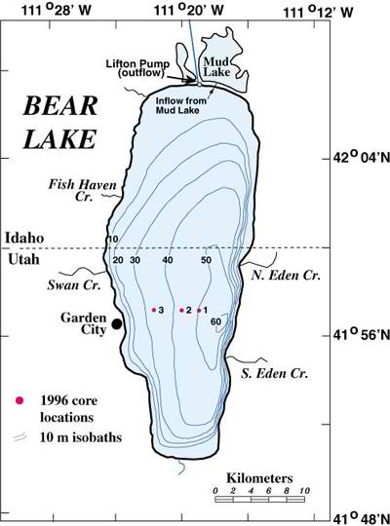
Bathymetric map of Bear lake, UT.

Geologic Maps
A geologic map shows the geological features of a region. Rock units are shown in a color identified in a key. On the map of Yosemite, for example, volcanic rocks are brown, the Tuolumne Intrusive Suite is peach and the metamorphosed sedimentary rocks are green. Structural features, for example folds and faults, are also shown on a geologic map. The area around Mt. Dana on the east central side of the map has fault lines.
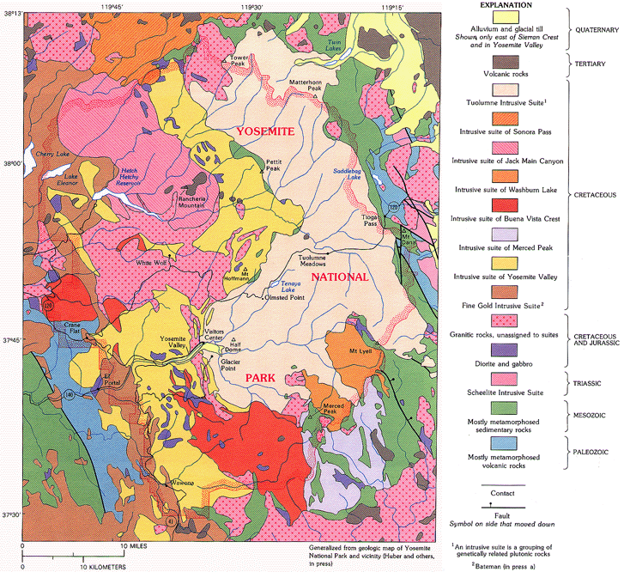
On a large scale geologic map, colors represent geological provinces.
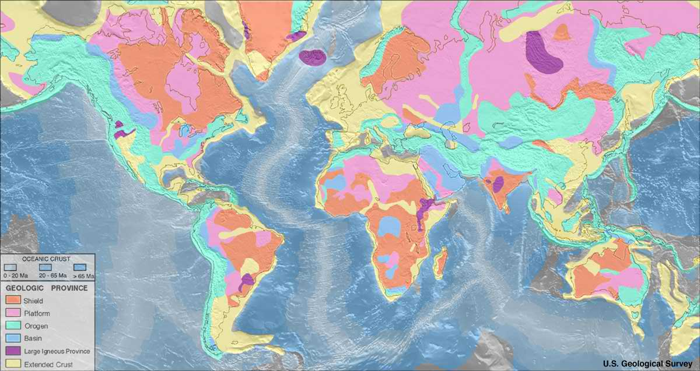

Lesson Summary
- Topographic maps are two-dimensional representations of the three-dimensional surface features of a given area. Topographic maps have contour lines which connect points of identical elevation above sea level.
- Contour lines run next to each other and adjacent contour lines are separated by a constant difference in elevation, usually noted on the map. Topographic maps have a horizontal scale to indicate horizontal distances. Topographic maps help users see the how the land changes in elevation.
- Many people use topographic maps to locate surface features in a given area, to find their way through a particular area, and to determine the direction of water flow in a given area.
- Oceanographers use a special type of topographic map called a bathymetric map, which shows the bottom of any given body of water.
- Geologic maps display rock units and geologic features of a region of any size. A small scale map displays individual rock units while a large scale map shows geologic provinces.

Review Questions
- On a topographic map, you see contour lines forming closed loops that all lie in the same area. Which of the following features would this indicate?
  - a stream channel
  - a hilltop
  - depression
  - a cliff
- Describe the pattern on a topographic map that would indicate a stream valley. How you would determine the direction of water flow?
- On a topographic map, five contour lines are very close together in one area. The contour interval is 100 ft. What feature does that indicate? How high is this feature?
- On a topographic map, describe how you can tell a steep slope from a shallow slope?
- On a topographic map, a river is shown crossing from Point A in the northwest to Point B in the southeast. Point A is on a contour line of 800 ft and Point B is on a contour line of 900 ft. In which direction does the river flow? What information would help you figure this out?
- On a topographic map, six contour lines span a horizontal distance of 0.5 inches. The horizontal scale is 1 inch equals 2000 ft. How far apart are the first and sixth lines?
- On a geologic map of the Grand Canyon, a rock unit called the Kaibab Limestone takes up the entire surface of the region. Down some steep topographic lines is a very thin rock unit called the Toroweap Formation and just in from that is another thin unit, the Coconino sandstone. Describe how these three rock units sit relative to each other.

Further Reading / Supplemental Links
- http://interactive2.usgs.gov/learningweb/teachers/mapsshow_lesson4.htm
- http://erg.usgs.gov/isb/pubs/booklets/symbols/topomapsymbols.pdf
- http://www.uwsp.edu/geo/faculty/ritter/geog101/textbook/manuals/instructor_manual/how_to/topographic_profile.html
- http://raider.muc.edu/~mcnaugma/Topographic%20Maps/topomapindexpage.htm
- http://www.globalsecurity.org/military/library/policy/army/fm/3-25-26/ch10.htm
- http://www.map-reading.com/intro.php

Vocabulary
bathymetric map
A special type of topographic map used by oceanographers that show depth of areas underwater.
contour interval
The constant difference in elevation between two contour lines on a topographic map.
contour lines
Lines drawn on a topographic map to show elevation; these lines connect all the places that are the same elevation.
topographic map
A special type of map that show elevations of different geologic features of a region.

Points to Consider
- Imagine that you are a civil engineer. Describe how you might use a topographic map to build a road, bridge, or tunnel through the area such as that shown in Figure 2.30. Would you want your road to go up and down or remain as flat as possible? What areas would need a bridge in order to cross them easily? Can you find a place where a tunnel would be helpful?
- If you wanted to participate in orienteering, would it be better to have a topographic map or a regular road map? How would a topographic map help you?
- If you were the captain of a very large boat, what type of map would you want to have to keep your boat traveling safely?

Using Satellites and Computers

Lesson Objectives
- Describe various types of satellite images and the information that each provides.
- Explain how a Global Positioning System (GPS) works.
- Explain how computers can be used to make maps.

Satellite Images
If you look at the surface of the Earth from your yard or street, you can only see a short distance. If you climb a tree or go to the top floor of your apartment building, you can see further. If you flew over your neighborhood in a plane, you could see still further. Finally, if you orbited the Earth, you would be able to see a very large area of the Earth. This is the idea behind satellites. To see things on a large scale, you need to get the highest view.
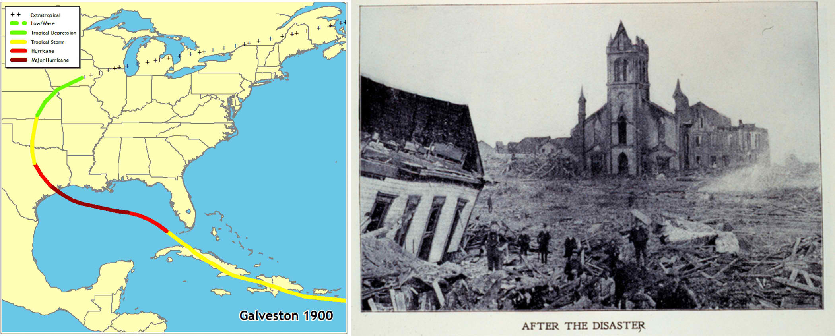
(left) Track of hurricane that hit Galveston, Texas on Sept. 8, 1900. (right) Galveston in the aftermath.
Let’s look at an example. One of the deadliest hurricanes in United States history hit Galveston, Texas in 1900. The storm was first spotted at sea on Monday, Aug 27, 1900. It was a tropical storm when it hit Cuba on Sept. 3rd. By Sept. 8th, it had intensified to a hurricane over the Gulf of Mexico. It came ashore at Galveston (Figure above). There was not advanced warning or tracking at the time. Over 8000 people lost their lives.
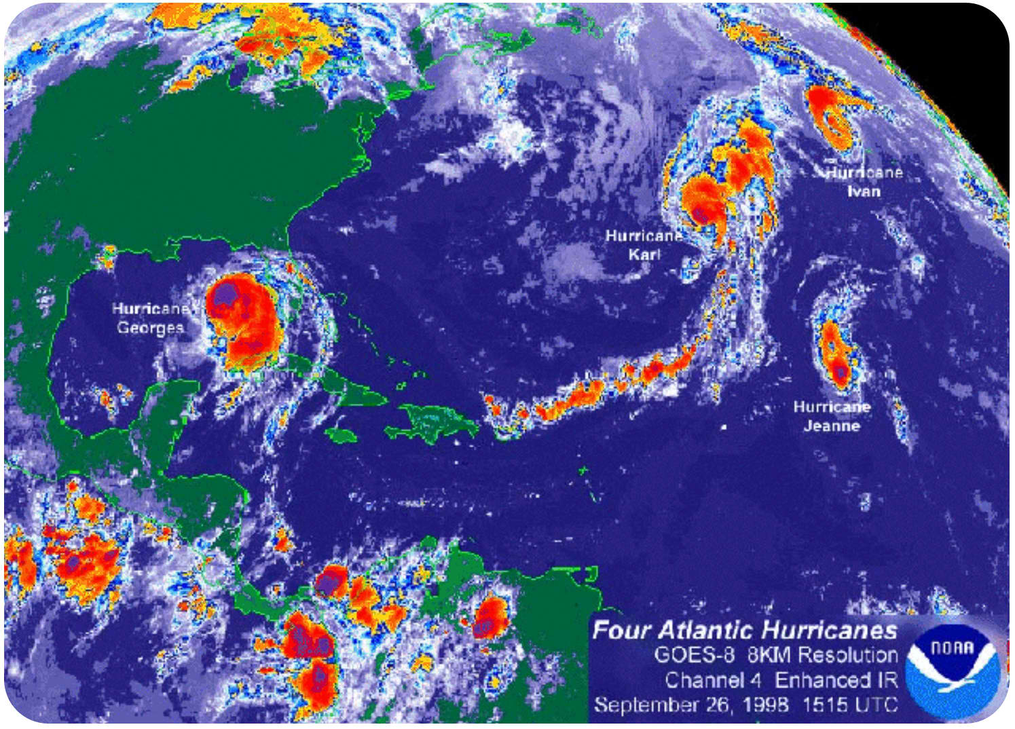
Satellite view shows four hurricanes in the Atlantic Ocean on Sept. 26, 1998.
Today, we have satellites with many different types of instruments that orbit the Earth. With these satellites, we can see hurricanes (Figure above). Weather forecasters can follow hurricanes as they move from far out in the oceans to shore. Weather forecasters can warn people who live along the coasts. Their advanced warning gives people time to prepare for the storm, which helps save lives.
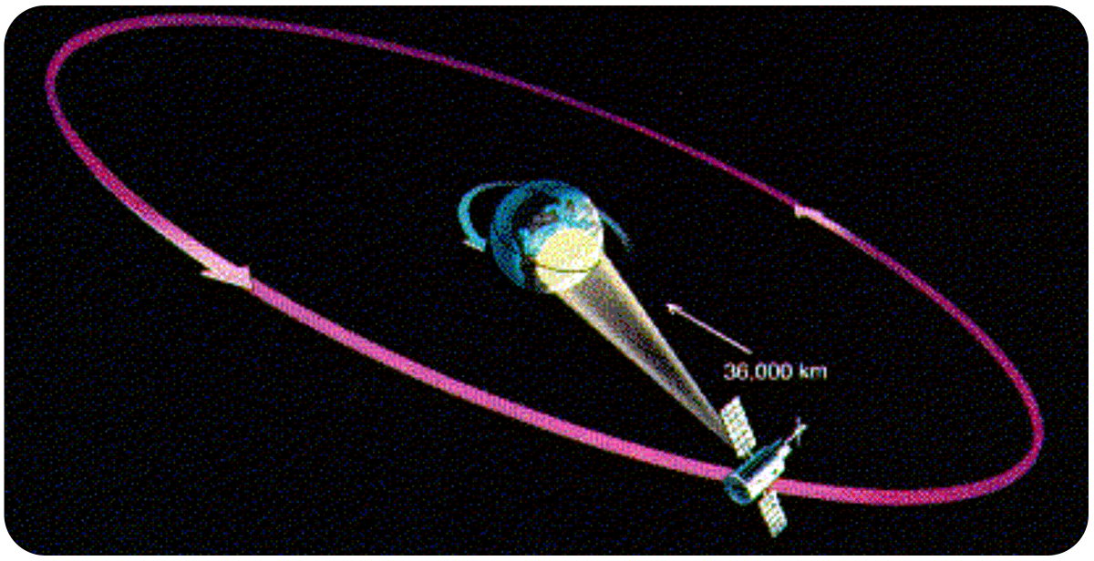
Satellite in a geostationary orbit.
Satellites orbit high above the Earth in several ways. One of the most useful ways is called the geostationary orbit (Figure above).
The satellite orbits at a distance of 36,000 km. It takes 24 hours to complete one orbit. Since the satellite and the Earth both complete one rotation in 24 hours, the satellite appears to “hang” in the sky over the same spot. In this orbit, the satellite stays over one area of the Earth’s surface. Weather satellites use this type of orbit to observe changing weather conditions. Communications satellites, like satellite TV, also use this type of orbit.
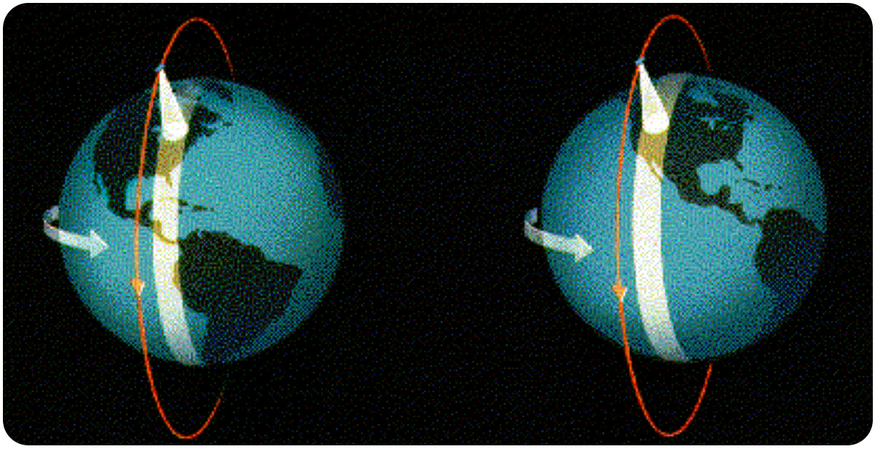
Satellite in a polar orbit.
Another useful orbit is the polar orbit (Figure above). The satellite orbits at a distance of several hundred kilometers. It makes one complete orbit around the Earth from the North Pole to the South Pole about every 90 minutes. In this same amount of time, the Earth rotates slightly underneath the satellite. In less than a day, the satellite can see the entire surface of the Earth. Some weather satellites use a polar orbit to get a picture of how the weather is changing globally. Also some satellites that observe the lands and oceans use a polar orbit.
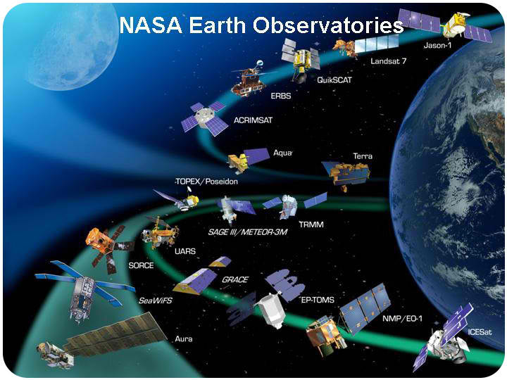
NASA
The National Aeronautics and Space Administration (NASA) has launched a fleet of satellites to study the Earth (Figure above). The satellites are operated by several government agencies, including NASA, the National Oceanographic and Atmospheric Administration (NOAA) and the United States Geological Survey (USGS). By using different types of scientific instruments, satellites make many kinds of measurements of the Earth.
- Some satellites measure the temperatures of the land and oceans.
- Some record amounts of gases in the atmosphere such as water vapor and carbon dioxide.
- Some measure their height above the oceans very precisely.
From this information, they can get an idea of the sea surface below.
- Some measure the ability of the surface to reflect various colors of light. This information tells us about plant life.
Some examples of the images from these types of satellites are shown in Figure below).
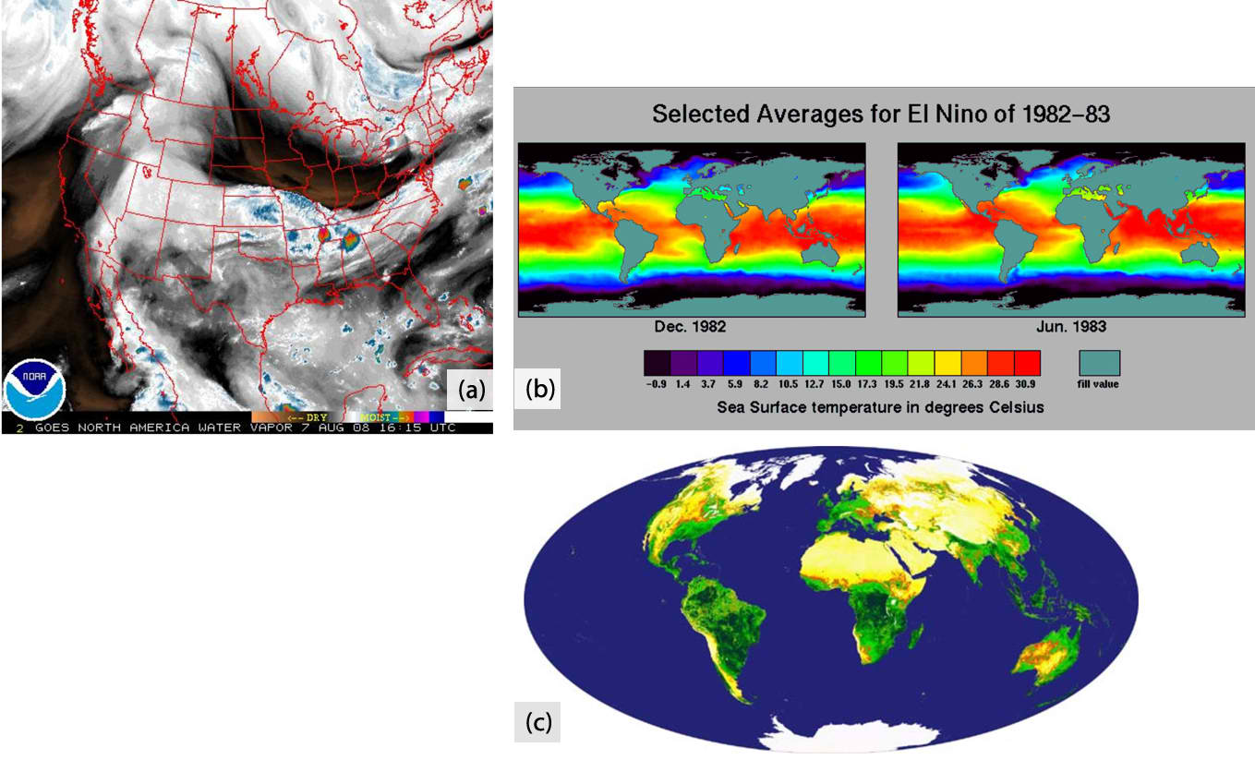
Various satellite images: A

Global Positioning System
Previously, we talked about your position on Earth. In order to locate your position on a map, you must know your latitude and your longitude. But you need several instruments to measure latitude and longitude. What if you could do the same thing with only one instrument? Satellites can also help you locate your position on the Earth’s surface (Figure below).
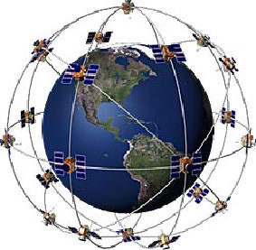
There are 24 satellites in the US Global Positioning System.
By 1993, the United States military had launched 24 satellites to help soldiers locate their positions on battlefields. This system of satellites was called the Global Positioning System (GPS). Later, the United States government allowed the public to use this system. Here’s how it works.
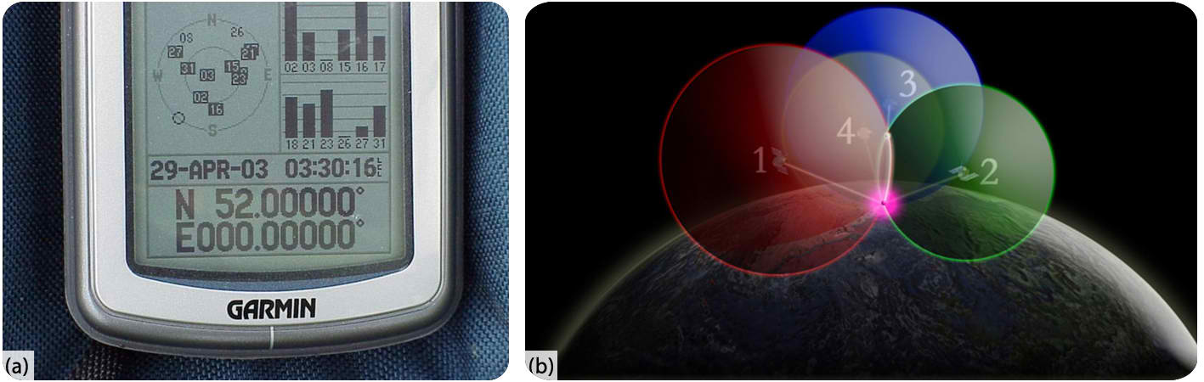
(A) You need a GPS receiver to use the GPS system. (B) It takes signals from 4 GPS satellites to find your location precisely on the surface
You must have a GPS receiver to use the system (Figure A above). You can buy many of these in stores. The GPS receiver detects radio signals from nearby GPS satellites. There are precise clocks on each satellite and in the receiver. The receiver measures the time for radio signals from satellite to reach it. The receiver uses the time and the speed of radio signals to calculate the distance between the receiver and the satellite. The receiver does this with at least four different satellites to locate its position on the Earth’s surface (Figure B above). GPS receivers are now being built into many items, such as cell phones and cars.

Computer-Generated Maps
Prior to the late 20th and early 21st centuries, map-makers sent people out in the field to determine the boundaries and locations for various features for maps. State or county borders were used to mark geological features. Today, people in the field use GPS receivers to mark the locations of features. Map-makers also use various satellite images and computers to draw maps. Computers are able to break apart the fine details of a satellite image, store the pieces of information, and put them back together to make a map. In some instances, computers can make 3-D images of the map and even animate them. For example, scientists used computers and satellite images from Mars to create a 3-D image of a large Martian valley called Valles Marineris (Figure below). The image makes you feel as if you are on the surface of Mars and looking into the valley.
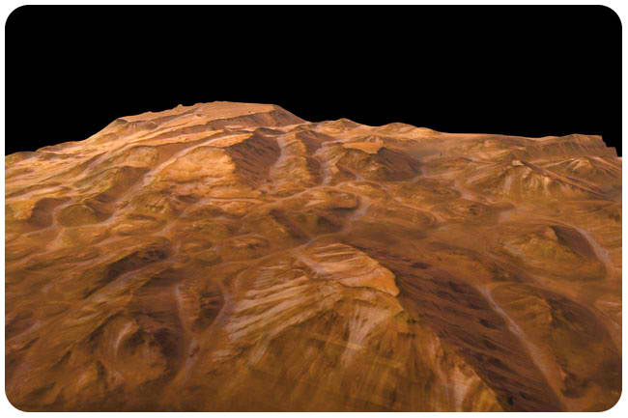
This three-dimensional image of a large valley on Mars was made from satellite images and computers.
When you link any type of information to a geographical location, you can put together incredibly useful maps and images. The information could be numbers of people living in an area, types of plants or soil, locations of groundwater or levels of rainfall for an area. As long as you can link the information to a position with a GPS receiver, you can store it in a computer for later processing and map-making. This type of mapping is called a Geographic Information System (GIS). Geologists can use GIS to make maps of natural resources. City leaders might link these resources to where people live and help plan the growth of cities or communities. Other types of data can be linked by GIS. For example, Figure below shows a map of the counties where farmers have made insurance claims for crop damage in 2008.
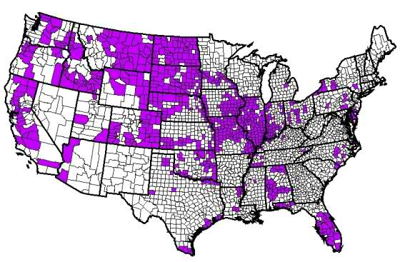
Map of insurance filings for crop damage in 2008.
Computers have improved how maps are made. They have also increased the amount of information that can be displayed. During the 21st century, computers will be used more and more in mapping.

Lesson Summary
- Satellites give a larger view of the Earth’s surface from high above. They make many types of measurements for earth scientists.
- A group of specialized satellites called Global Positioning Satellites help people to pinpoint their location.
- Location information, satellite views, and other information can be linked together in Geographical Information Systems (GIS).
- GIS are powerful tools that earth scientists and others can use to study the Earth and its resources.

Review Questions
- Which type of satellite can be used to pinpoint your location on Earth?
  - weather satellite
  - communications satellite
  - global positioning satellite
  - climate satellite
- Explain the difference between geosynchronous orbits and polar orbits?
- Describe how GPS satellites can find your location on Earth?
- What is a Geographical Information System or GIS?
- If you want to map the entire Earth’s surface from orbit, which type of orbit would you use?
- Explain how weather satellites could track a tropical storm from its beginnings?

Further Reading / Supplemental Links
Nous, A., “Satellite Imaging,” The Science Teacher, Dec. 1998. Available on the Web at:
- pdf. http://www3.nsta.org/main/news/pdf/tst9812_46. pdf.
"Isaac’s Storm": Available on the Web at:
- http://www.randomhouse.com/features/isaacsstorm/.
USGS, Geographic Information Systems
- http://erg.usgs.gov/isb/pubs/gis_poster/
GIS.com, What is GIS?
- html http://www.gis.com/whatisgis/index. html
USGS Topographical Mapping
- http://erg.usgs.gov/isb/pubs/booklets/topo/topo.html
- http://www.ccpo.odu.edu/SEES/index.html
- http://earthobservatory.nasa.gov/
- http://www.noaa.gov/satellites.html
- http://landsat.usgs.gov/
- http://school.discoveryeducation.com/lessonplans/programs
- http://oceanexplorer.noaa.gov/explorations/07mexico/background/navigation/navigation.html
- http://www.geoplane.com/gps. html
- http://oceanservice.noaa.gov/education/kits/geodesy/geo09_gps. html

Vocabulary
Geographic Information System (GIS)
An information system that links data to a particular location.
geostationary orbit
A type of orbit that allows a satellite to stay in above one location on Earth's surface.
polar orbit satellite
Orbit that moves over Earth's north and south poles as Earth rotates underneath.

Points to Consider
- Imagine that you are tracking a hurricane across the Atlantic Ocean. What information would you need to follow its path? What satellite images might be most useful? Research and explain how the National Weather Service tracks and monitors hurricanes.
- If you had to do a report on the natural resources for a particular state, what type of map would help you find the most information?
- What are some ways that people use Global Positioning Systems? What problems are easier to solve using GPS?

