HOW TO FILL OUT YOUR LOGS ELECTRONICALLY:

I have your logs from your files at school. If you seem to be missing time before we went on break, I’ll speak to you about it individually.

Here is a little guidance in expectations for log type classes from here out

For PE: If you had a vendor (gym or karate lessons) just practice the best you can each day at home. I am still looking for 60 minutes of PE daily for an A. Remember that physical activity is a stress-buster and we could all use a little of that at the moment. There are tons of free videos online, if you need them. Feel free to use this time to try something new!

For Work Experience and Community Service: you must spend at least 30 minutes PER DAY doing some task or tasks that are of service to others in your home. It can be helping your parents by occupying younger siblings, doing a task or chore that you would not normally do for someone else (not clean your room) such as a load of laundry washed, dried and put away, dusting, organizing, meal prep, take out garbage, etc. It has to be work that you are not normally expected to do.

For Music: Practice for 30 minutes per day. To grow your abilities, you could find YouTube videos to learn a new piece. In order to get credit, you must be learning and practicing new material, you must do it regularly, and you must be making improvement.

Going forward, this is how you’ll keep your log(s).

FILLING OUT YOUR ELECTRONIC LOG:

1. Log in to your student portal.

2. Select Activities Log:

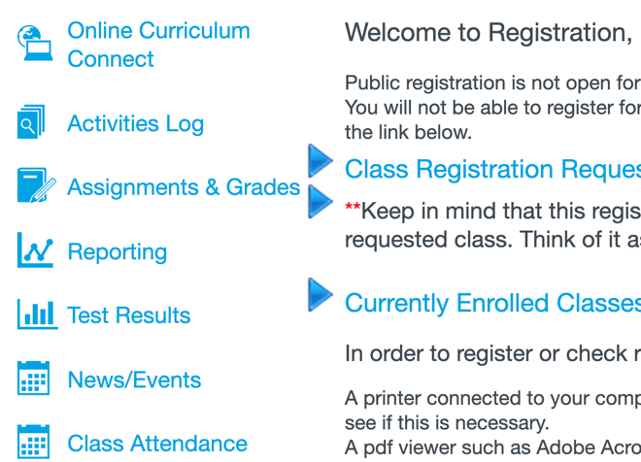

3. Select the ‘Report Title’ you need from the drop-down box (for community service pick work experience).
Select the ‘Log Type’ you need from the drop-down box, (DON’T use “grid log-check”).

When finished, click ‘Review Log.’

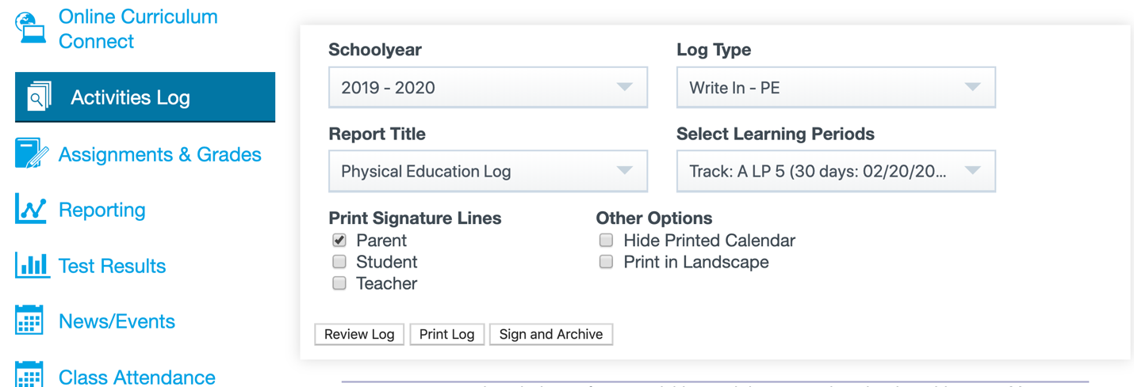

4. Scroll down to the current week. Type in what you did each day and put your time in, too.
You don’t need a proper sentence, a list will do, but try to spell correctly so I don’t have to guess what you mean. At the end of the LP, I will record your total your time and record your grade.

