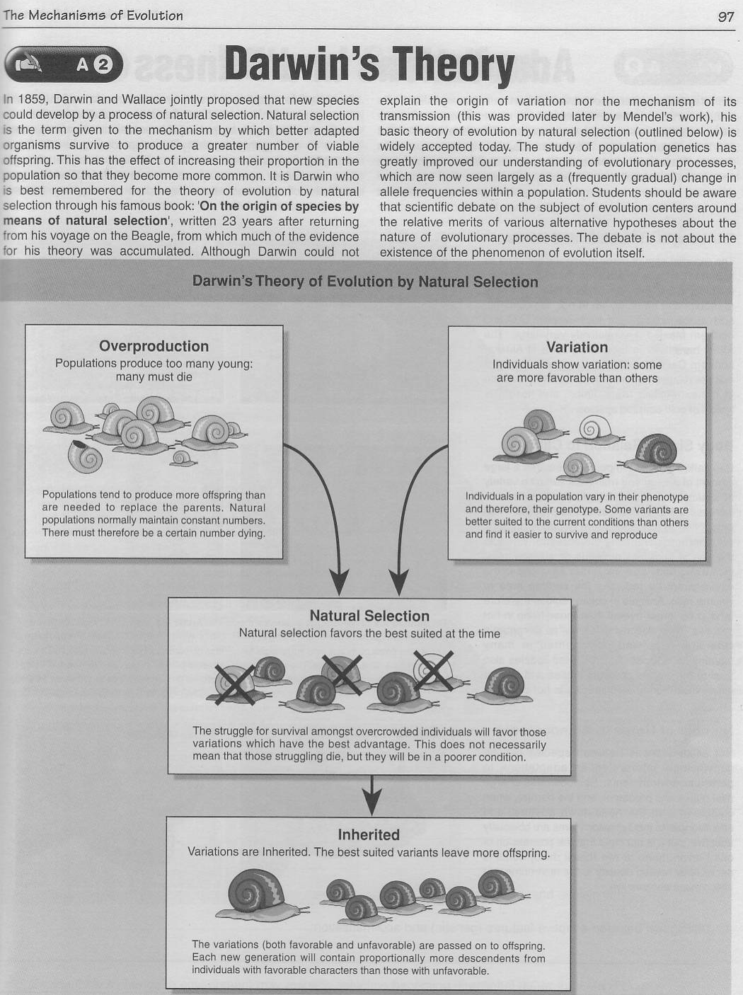
- Based on the reading, how does natural selection explain the evolution of the giraffe’s neck?

- Why do organisms overproduce?

- In your own words, explain natural selection and the 4 steps.

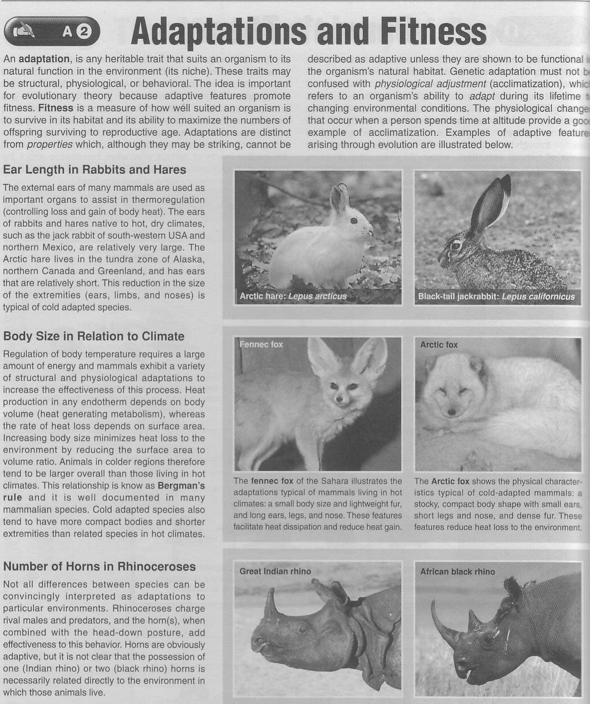
- Distinguish between adaptive features (genetic) and acclimatization:

- Explain the nature of the relationship between the length of extremities (such as limbs and ears) and climate:

- Explain the adaptive value of a larger body size at high altitude:

