Plate Tectonics 1

•The theory of plate tectonics states that the Earth's surface consists of large regions known as plates, which are made up of the Earth's crust and the brittle portion of the lithosphere. These plates move on the more plastic aesthenosphere.

•Why is the Theory of Plate Tectonics such a tremendous deal? Why do geologists harp on it so much?

•It is essentially a new paradigm, or world view. It provides a global framework for the interdependent nature of geologic processes, rather than looking at events as unrelated.

A History of the Theory of Plate Tectonics
•Plate Tectonic theory owes its birth to Alfred Wegener, a geologist who was actually a meteorologist more interested in ancient climate than the Earth's interior.

•This scientist, noting the close fit of the S. American and African coastlines, and trying to explain the migratory patterns of flora and fauna from various regions across the Atlantic Ocean, suggested the presence of a supercontinent in the past. This was the first time it was suggested that the continents were not static constructs.

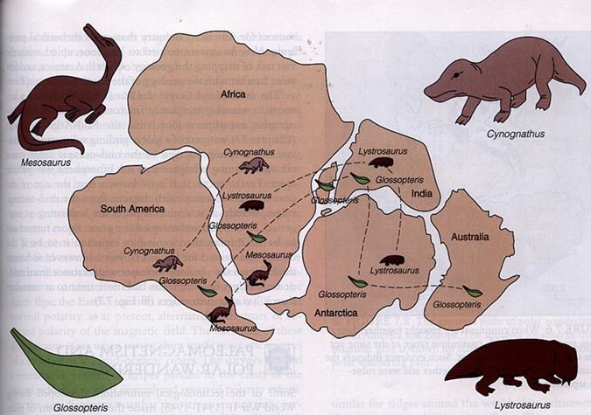

The Evidence
•Glacial features were visible from about 220 to 250 million years ago in the Southern Hemisphere, but no such evidence was found for that time period in the Northern Hemisphere. The implication was that polar areas of the continents would have shared glacial features if they were in the same position 220 million years ago as they are now. But, in fact, at that time, the continents currently in the Northern Hemisphere had a tropical climate. Either glaciers existed at the equator, moving from ocean to land, or the continents have moved from their present position.

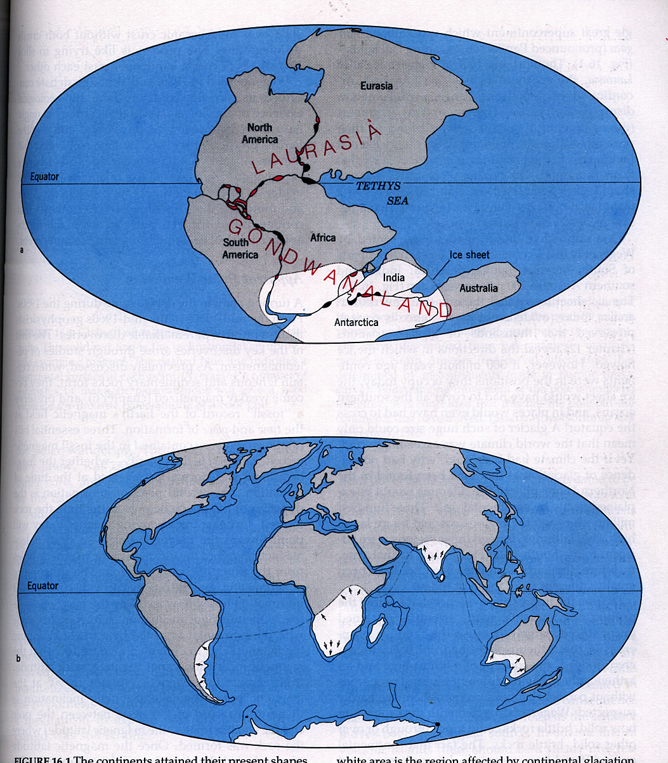

White areas show the position of glaciers 200 million years ago.

•Fossil evidence for continental movement is strong. Again, the southern continents provide this evidence, in the form of a very uniform collection of plants and animals. Even though the continents now range from polar to tropical in climate, the floral/faunal evidence indicates that these regions were once very similar in climate and in their complement of plant and animal life. In addition, seeds of some of these plants cannot be borne by wind, as well as water.

•A matchup also occurs when looking at the fossils of certain animals. Some fossils are found only in very small areas of Brazil and Africa that just happen to match up when the continents are pieced together.

•Continents fit together as well, especially when the actual boundaries of the continents (the continental shelves) are examined. Regions of high erosion (river deltas) match up less well.

•Mountains appear to end at the edge of one continent and continue on another continent across an ocean. Appalachians match with Greenland, Ireland, Britain, Norway.

Pangaea and Continental Drift
•The result of Wegener's work was Pangaea, the hypothesis that a supercontinent once existed, composed of all the continents combined. This continent fragmented in the Triassic and the continents drifted apart. Unfortunately, because he had no satisfactory hypothesis for how the continents actually drifted, his ideas were not widely accepted.

•Part of the problem was simply that geology was a very young science and most geologists were too busy worrying about describing what they observed than the underlying processes. This is a typical evolution for a science.

Modern evidence
Crustal age, sediment thickness
•Recent (1950s) evidence was much more conclusive: Oceanic crustal age, sediment thickness and the presence of a mid-ocean ridge, were all as expected if the crust was pulling apart and new crust was being created at the ridge.

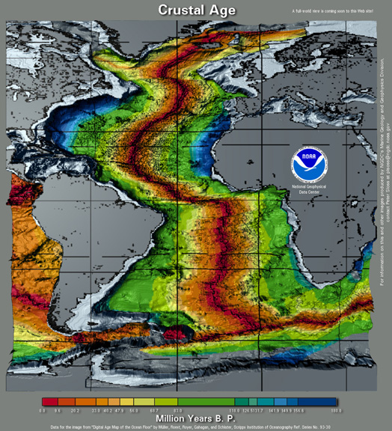

•The invention of magnetometers for locating submarines also provided a boon for geologists in that they were able to detect the weak magnetism of iron-bearing minerals on the oceanic crust. These minerals align themselves with the Earth's magnetic field when they are still in semi-liquid state, leaving a record of the strength and direction of the magnetic field.

•It was discovered that the poles occasionally reverse; that is, the north and south magnetic poles changed positions. When the mid-ocean ridges were examined globally by magnetometers, it was discovered that there was a pattern of symmetrical magnetic stripes parallel to the ridges, which recorded each of the normal and reversed polarity events.

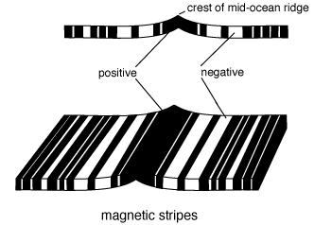

•Each stripe on one side of the ridges was matched by a stripe of equal width and magnetic polarity on the other side, and the pattern was repeated all over the world.

•Seafloor spreading accounts for these magnetic patterns, in that as magma rises from the center of a mid-ocean ridge, iron-bearing minerals are magnetized in the direction of the Earth's magnetic field. The magma cools with the remnant magnetism recorded in its minerals.
•As the lithosphere spreads apart and new material is added at the ridge, the various reverses in the Earth's magnetic field are recorded.

•The magnetic fields in rocks of various continents also suggest that the continents were all in one place. Either that, or the Earth had dozens of poles at the same time.

Earthquakes and trenches
•It was shown that the location of earthquake epicenters occurring near deep-ocean trenches coincided with sloping planes plunging from the trench into the Earth. These epicenters trace out regions where plates are subducting, or diving back into the Earth's interior.

Refining the Theory: What does the Theory of Plate Tectonics Explain?
•Again, the theory of plate tectonics states that the Earth's surface is made up of large regions called plates. These plates make up the lithosphere, which is composed of the crust and the colder, brittle part of the upper mantle. The plates of the lithosphere move on the aesthenosphere, a less brittle (more deformable) part of the upper mantle.

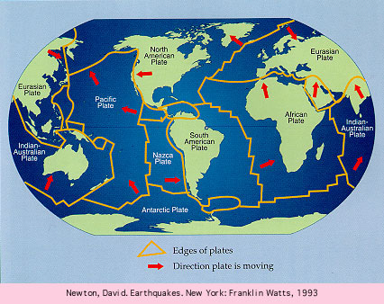

•A quick note on the difference between crust and lithosphere. These two terms reflect the difference between a chemical or compositional boundary (crust vs. mantle) and a mechanical boundary (brittle lithosphere vs. plastic aesthenosphere). The crust is part of the lithosphere, rather than the other way around.

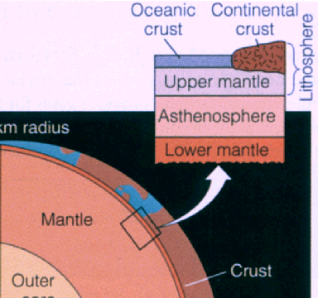

•Plates can consist of oceanic (denser basaltic crust created at mid-ocean ridges) and continental crust (less dense crust). Each will move in different directions and at different speeds. These speeds range from about 2 -10 cm/yr.

•Because each plate moves at a different direction and speed, the plates themselves are commonly geologically quiet, but regions where plate meets plate (boundaries) are areas of intense geologic activity.

•The theory of plate tectonics thus provides explanations for nearly every facet of Earth geology, including:
Earthquakes These tend to be focussed, as noted above, along plate boundaries. The best known example of this in the United States is the earthquake zone along the San Andreas Fault, the boundary between the North American and Pacific plates.
Volcanoes Other than hotspot volcanoes, these cluster along plate boundaries as well, commonly near the deep-ocean trenches that define subduction zones. Areas include the islands of Japan, and the Andes and Cascade mountain ranges. The "Ring of Fire" around the Pacific Ocean defines for the most part the outline of the Pacific plate.
•Sea Level The ocean level can be influenced by the speed at which a mid-ocean ridge spreads, sloshing water on the continental shelves.
Geologic Features The globe-girdling system of mid-ocean ridges, deep-ocean trenches, many continental mountain ranges, both volcanic and non-volcanic, rift zones such as that at the Red Sea, all lie on and are the result of plate boundaries.

Types of Plate Boundaries
•There are three main types of plate boundaries: divergent, convergent and transform.

Divergent Plate Boundary
•This is a boundary where plates are moving apart from each other, with new crust created from mantle material upwelling into the gap.

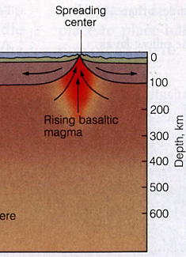

•Defined by a ridge less than a km wide, split by a narrow graben, or rift valley. Within the graben are the fissures that are source vents for upwelling mantle material. Hotter crust near the rise is less dense than cooler crust moving away from the rise; thus, the ocean depth increases as one moves away from the rise.

•Found under the ocean, at places such as the Mid-Atlantic Ridge and the East Pacific Rise. Also found at rift systems such as that under the Red Sea (the East African Rift Zone). These continental rift systems are proto-oceans.

Convergent Plate Boundary
•This is a boundary in which plates are converging on each other. Either the plates collide and crunch together, or the thinner, denser plate (commonly an oceanic plate) dives underneath the thicker, less dense plate (either oceanic or continental).

•At a subduction zone, the thinner, denser plate is almost always an oceanic plate. This plate sinks into the mantle. As it descends and dips into the mantle, creating a trench at the plate boundary on the ocean floor, it heats as well.

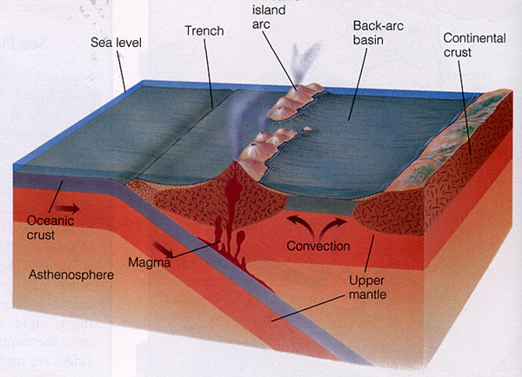

•At a depth of about 100 km, the descending plate begins to melt, releasing magma and volatiles (water) into the overlying crust. If this magma reaches the surface, it often erupts as andesitic lava. Otherwise, it may form intrusive magma bodies. This volcanic activity is focussed about 100 km inward of the plate boundary.

•Examples: The Andes mountain range; the Japan volcanic chain, the volcanic islands of the South Pacific; the Aleutian Islands.

•Plates can also collide during convergence. This happens most often when two light, thick continental plates converge. In this case, crust is not necessarily destroyed, but is deformed and crunched together, forming mountain ranges.

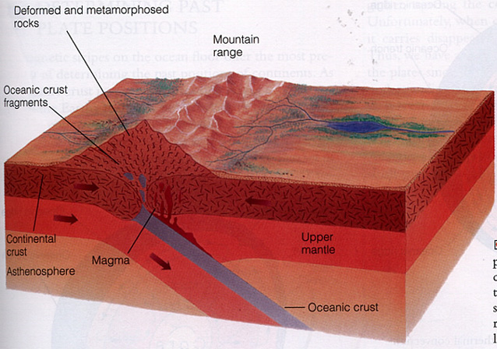

•Example: The best example is the Himalayan mountain range, where the Indian plate is colliding with the Eurasian plate.

Transform Fault Plate Boundary
•At a transform fault, two plates are sliding past each other.

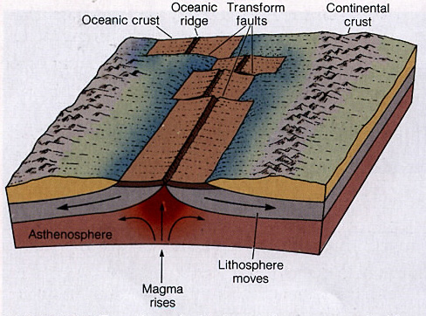

•This type of fault does not create the same amount of internal energy as the other two boundaries, so volcanism is not usually associated with this boundary. Earthquakes are, however.

•This type of boundary is also not as long as the other two types.

•Transform faults occur most often at mid-ocean ridges, as the two divergent plates try to move unequally over the curved surface of the Earth. The rotation motion is taken up by small (relative to the divergent boundary) transform faults.

•Example: The best-known transform fault is likely the San Andreas fault.

Special Features: Hot Spots
•In hot spot volcanism, volcanic activity is the result of a persistent conduit for plumes of liquid hot magma deep in the mantle, known as a hot spot. This hot spot continually pumps magma up to the Earth's surface, producing volcanism.

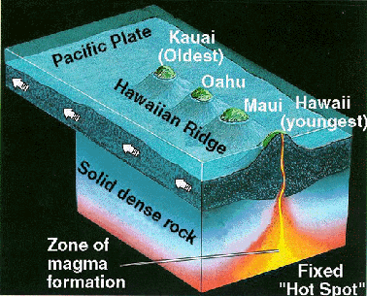

•This conduit does not move, but the plate above it does. Thus, the location of maximum volcanism changes with time.

•The best known example of a hot spot is found at the Hawai'ian-Emperor Island chain. Here, the movements of the Pacific plate can be traced by following the island chain from the Big Island of Hawai'i past Midway and on under the ocean floor to the submerged volcanos called seamounts that have been eroded away over time to below sea level. Off the southeastern shore of Hawai'i is the seamount called Loihi, the next Hawai'ian island.

